Bluffton Exempted Village Schools
Board of Education Agenda
Elementary Media Center
February 18, 2019

REGULAR MEETING …………………………………………………………………………………….7:30 P.M.

1. CALL TO ORDER:
The meeting is called to order by Wes Klinger.
Members present:

Mr. Fruchey
Mr. Klinger
Mr. Lugibihl
Mr. Scoles
Mrs. Smith

2. APPROVAL OF AGENDA:
______________ moved, seconded by ____________ to approve the agenda as (printed) (modified).

Mr. Klinger
Mr. Lugibihl |  | Passed
Mr. Scoles |  | Failed
Mrs. Smith |  | Vote
Mr. Fruchey

3. APPROVAL OF MINUTES & REPORTS:
_____________ moved, seconded by __________ the following be approved:

- Minutes of the January 14, 2019 re-organizational/regular meeting
- January 31, 2019 treasurer’s financial and investment reports as submitted

Mr. Lugibihl
Mr. Scoles |  | Passed
Mrs. Smith |  | Failed
Mr. Fruchey |  | Vote
Mr. Klinger

4. INVOLVEMENT OF VISITORS:

5. CONTRACTS, ASSIGNMENTS & ETC.:
___________ moved, seconded by ___________ having passed the criminal record check and certification
requirements as determined by the State of Ohio Department of Education, the following
contracts/assignments, and changes be approved::

- Substitute Teacher at $85.00 per day taught 2018-2019:
Stacey Freed Fibafoluwa Balogun Scott States
Rachael Brown Laura Ayers Jennifer Hutchinson

- State Testing Tutors 2018-2019:
Bonnie Hammond be issued a contract for the period February 19, 2019 – April 17, 2019 at $85.00 per day worked to be paid out of Title I Targeted Assistance fund.

Liane Thompson be issued a contract for the period February 19, 2019 – April 17, 2019 at $85.00 per day worked to be paid out of Title I Targeted Assistance fund.

- Supplemental Contracts 2018-2019:

Activity | Employee
Head High School Track | William Theisen
High School Track Coordinator | Shawn Ribley
High School Assistant Track | Jeffery Baker
High School Assistant Track | Jason Diller
Volunteer High School Track | Rachel Mathewson
Head Baseball | Mason Roth
Assistant Baseball | Braeden Edwards
Volunteer Baseball | Steven Edwards
Head Softball | Anthony Rumer
Assistant Softball | Darryl Willis
Head Boys Tennis | Michael Hilty
Head Middle School Track | Brandie Stackhouse
Middle School Assistant Track | Jaime Combs

- Supplemental Contracts 2019-2020:

Activity | Employee
Head High School Football | Jeffrey Richards
Head Girls Soccer | Jared Byers
Head Boys Soccer | Stephen Smucker
Head Golf | Mason Roth
Head High School Volleyball | Kevin King
Head Cross Country | William Theisen

The Board reserves the right to treat any offer of employment as withdrawn if the contract is not signed and returned within ten (10) business days of mailing.

Mr. Scoles
Mrs. Smith |  | Passed
Mr. Fruchey |  | Failed
Mr. Klinger |  | Vote
Mr. Lugibihl

6. AMOUNTS & RATES RESOLUTION:

______________ moved, seconded by ____________ the Amounts and Rates be approved as

determined by the Budget Commission as follows:

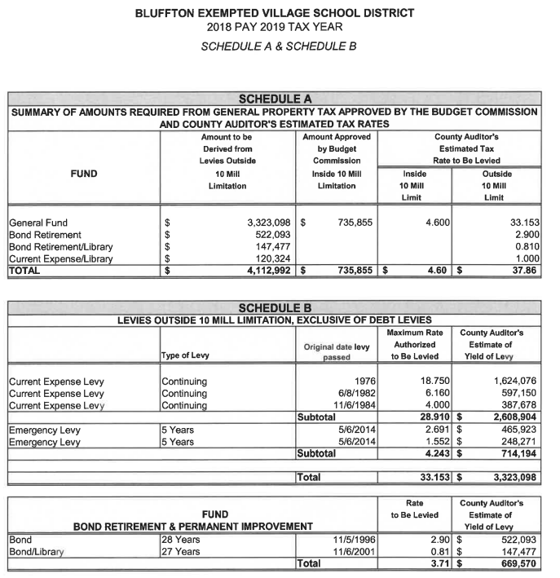

Mrs. Smith
Mr. Fruchey |  | Passed
Mr. Klinger |  | Failed
Mr. Lugibihl |  | Vote
Mr. Scoles

7. APOLLO REPORT:

8. ADMINISTRATIVE REPORTS:

9. EXECUTIVE SESSION:

At ______ p.m. __________ moved, seconded by ________ the Bluffton Exempted Village Board of

Education enter into executive session to discuss employment of personnel.

Mr. Fruchey
Mr. Klinger |  | Passed
Mr. Lugibihl |  | Failed
Mr. Scoles |  | Vote
Mrs. Smith

The Board Returned to regular session at _______p.m.

10. ADJOURNMENT:
At ___________ p.m. ___________ moved, seconded by ___________ the meeting adjourn.

Mr. Klinger
Mr. Lugibihl |  | Passed
Mr. Scoles |  | Failed
Mrs. Smith |  | Vote
Mr. Fruchey

In order for the Board to fulfill its obligation to complete the planned agenda in an effective and efficient fashion, a maximum of 30 minutes of public participation may be permitted at each meeting. Each person addressing the Board shall give his/her name and address. If several people wish to speak, each person is allotted three minutes until the total time of 30 minutes is used. During that period, no person may speak twice until all who desire to speak have had the opportunity to do so.

Bluffton Exempted Village Schools
Board of Education Agenda
Elementary Media Center

February 18, 2019 Regular Meeting 7:30 P.M.

- Call to Order
- Approval of Agenda
- Approval of Minutes & Reports
- Involvement of Visitors
- Contracts, Assignments & ETC.
- Amounts & Rates Resolution
- Apollo Report
- Administrative Reports
- Executive Session
- Adjournment

