**Other Music Ensembles**

**District III Honors Choir/Band/Jazz Band**

|  |  |  |
| --- | --- | --- |
|  |  |  |

**District III Junior High Honors Choir/Band/Jazz Band**

|  |  |  |
| --- | --- | --- |
|  |  |  |

## Lima Area Youth Orchestra

|  |  |
| --- | --- |
|  |  |

*With the pandemic, all of the aforementioned honor groups took a hiatus this year. It is our hope that we will again have several students participating in these amazing ensembles next year!*

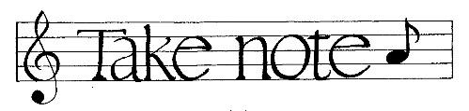

**Who are the Music Boosters?**

If you have a child involved in any of the music programs at Bluffton Schools – elementary, middle school or high school- you are a music booster! You are welcome to attend the Music Booster meetings which are held in the High School band room at 7:00 pm on the first Monday of the month.

**How do we raise money?**

* Football concession stand
* Annual fundraisers
* Chicken BBQ
* Donations at music concerts throughout the year

**Where does your money go?**

Bluffton Music Boosters exist to support the music programs in the Bluffton Schools. The following are some of the major items you have helped purchase for the various music programs this year:

* Purchase new choir robes
* Purchase new band instruments
* Music Awards
* Show choir choreographer
* Recorders for 4th graders
* Subsidize field commander camp
* Many other instrument repairs, supplies, etc.!

Bluffton Music Boosters

Annual

Chicken Barbecue

and Concert



Saturday, March 27, 2021

Virtual!

**Bluffton Music Teachers**

|  |  |
| --- | --- |
| **Alice Basinger** | Elementary Music |
| **Rachael E. Lewis** | Orchestra Director |
| **David B. Sycks** | Band Director |
| **Kara Zink** | Choir Director |
| **Noah Floyd** | Student Teacher |
|  |  |

**Performance Schedule**

|  |  |
| --- | --- |
|  | **4th Grade/5th Grade Orchestra** |
|  |  |
|  | **Choir 7** |
|  |  |
|  | **Band 5** |
|  |  |
|  | **6th Grade/ 7th & 8th Grade Orchestra** |
|  |  |
|  | **Choir 8** |
|  |  |
|  | **Band 6** |
|  |  |
|  | **Choir 6** |
|  |  |
|  | **Band 7&8** |
|  |  |
|  | **High School Orchestra** |
|  |  |
|  | **Concert Band** |
|  |  |
|  | **High School Choirs** |
|  |  |
|  | **Show Choir** |
|  |  |
|  | **Jazz Band** |
|  |  |
|  |  |

**Jazz Band**

Skyliner Barnet/Taylor

Caitlyn Couch – *piano, Ben Eiden – tenor sax, will Neff – trumpet*

Big Noise from Winnetka Crosby/Lavender

Eli Okuley – drums, Libby Frazier – *alto sax*

Harlem Nocturne Hagen/Berry

Libby Frazier – *alto sax*

In the Mood Joe Garland

Libby Frazier – *alto sax, Ben Eiden – tenor sax, Will Neff - trumpet*

Jumpin’ at the Woodside Basie/Covey

Ben Eiden – *tenor sax, Ellie Wright – alto sax*

|  |  |  |
| --- | --- | --- |
| Saxophones | | Trumpets |
| Libby Frazier, lead alto | | Hannah Davis, lead |
| *Tre’ Bender, alto 2 | | Will Neff, 2 |
| Alyssa Hoffman, alto 2 | | *Elizabeth Bourassa, 3 |
| *Ben Eiden, tenor 1 | | Adanna Johnstone, 3 |
| Nathan Meyer, tenor 2 | | Madison Sampson, 4 |
| *Carlin Mathewson, bari | | Taylor Follas, 4 |
|  | |  |
| Trombones | | Rhythm |
| Cole Bowers, lead | | Caitlyn Couch, piano |
| Caitlyn Couch, 2 | | Jonah Brown, bass |
| John-Paul Yoder, bass bone | | Eli Okuley, drums |
|  | | *Ellie Wright, guitar |
| *\* senior member* |

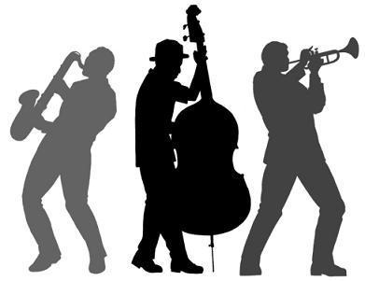

**Show Choir**

*Look for this performance video later in the spring…*

|  |  |  |
| --- | --- | --- |
| Theo Andreas | *Nick Jebsen | *Melina Meza |
| Tré Bender | *Tayton Kleman | Isaiah Mikesell |
| *Elizabeth Bourassa | Thayne Kleman | Ellie Nickel |
| Wes Brauen | Grant Klinger | Ian Rieman |
| *Derek Carr-Lane | Leah Klinger | Kiera Rieman |
| Ella Cunningham | Gavin Kruse | Landon Shutler |
| Riley Eachus | Abbie Lemley | *Julia Smallcombe |
| Libby Frazier | *Clara Matthews | Kayla Van Atta* |
| Jordyn Garmatter | Olivia Matthews | Eli Wenger |
| Riley Greer | Ayden McDougle | Addy Wright |
| Amy Jebsen |  |  |
|  |  |  |

*senior show choir member

Choreography by Amber Shelly



**4th Grade Orchestra**

Up and Down on the D and A Strings!

German Dance Song

Cradle Song

Twinkle, Twinkle Little Star

|  |  |  |
| --- | --- | --- |
| Violin | Leah Hoffman | Viola |
| Caydence Bassett | Elijah Lewis | Anna Honse |
| Bodey Benroth | Hayley Maag | Adalynn Rettig |
| Ryan Blount | Morgan Martini | Piper Culver |
| Evan Blue | Jorian Mast | Grayson Dukes |
| Evelyn Boyles | Elyse Montel |  |
| Jorge Cedeno | Kaden Niekamp | Cello |
| Celia Clinger | Anistyn Rhoad | Zach Evans |
| Sophia Erter | Levi Shepler | Gabrielle Harris |
| Liliana Fleming | Leah Shipman | Ciara Keysor |
| Gabriel Foster | Logan Stechschulte | Charlotte Kidd |
| Savanna Gossman | Madelyn Sterrett | Aubrey Maag |
| Georgia Hagen | Anya Thomason | Hailey Utendorf |
|  | Cole Weissling | Kristopher Tipton |
|  |  | Joey Richardson-Miller |
|  |  |  |

**5th Grade Orchestra**

Old Mac Fiddle arr. John Higgins

Regalia Carl Strommen

Cabbage Countdown arr. Bob Phillips

|  |  |  |
| --- | --- | --- |
| Violin 1 | Violin 2 | Violin 3 |
| Kennedy Longworth | James LaRue | Trinity Chambers |
| Alex Nance | Brooks Schwarz | Serenity O’Connell |
|  | Hephaestion Weyer |  |
| Cello |  |  |
| Owen Armstrong |  |  |
| Peighton Bowers |  |  |
|  |  |  |
|  |  |  |
|  |  |  |

**Choir 7**

I Just Wanna Shine arr. Mac Huff

There’s A Hero arr. Cristi Cary Miller

Liliana Liberato - solo

Born to Be Brave arr. Mac Huff

|  |  |  |
| --- | --- | --- |
| Emma Beach | Jayden Foust | Makenna Mohr |
| Brooklyn Bible | Luke Ginther | Jaicelyn Morris |
| Claire Blackburn | Emily Granger | Alayna Mueller |
| Ethan Blount | Ellie Hartzler | Adrian Murray |
| Jonah Boisvert | Rylee Hasting | Ryleigh Myers |
| Lauren Bowers | Riley Herriman | Brooklyn Nance |
| Jackson Bowlus | Allison Herrmann | Hannah Nieman |
| Aubrey Burkholder | Ethan Hoffman | Madison Omlor |
| Keith Burkholder | Elizabeth Honse | Claire Phillips |
| Oliver Combs | Kaedence Ingram | Aubrey Rieman |
| Grace Conley | Wyatt Knauss | Rilye Sanders |
| Grady Coonfare | Joe Lewandowski | Macy Schaadt |
| Vanessa Cross | Liliana Liberato | Lily Schneck |
| Lilly Dagani | Charleigh Link | Blaize Schwartz |
| Karleigh Davis | Nick Lovett | Madison Shepherd |
| Lauren Dearth | Emma McCall | Ali Shilling |
| Calvin Derstine | Hunter McColloch | Ava Smallcombe |
| Maizie Digby | Brianna McDonald | Zyven Smith |
| Dillon Doctor | Kya McDougle | Kendall Stackhouse |
| Jenna Downey | Mya McDougle | Elizabeth Suter |
| Bella Ellerbrock | Ashley McLaughlin | Yasmin Teixira |
| Ella Fairburn |  |  |



**High School Choirs**

This Little Light of Mine arr. Neil A. Johnson

Amy Jebsen – piano

Just Sing arr. Roger Emerson

Follow the Drinking Gourd arr. Victor C. Johnson

Caitlyn Couch – *piano*

Hakuna Matata arr. Roger Emerson

Don’t Give Up on Me arr. Mac Huff

Stand By Me arr. Roger Emerson

Chamber Choir

**High School Choirs**

|  |  |  |
| --- | --- | --- |
| Eden Antrim | Justin Good | Kaley Mathewson |
| Landon Armstrong | Jenna Goodman | Olivia Matthews |
| Makenzie Badertscher | Jessica Goodman | *#Ayden McDougle |
| Destinee Bandagski | Sophia Goodwin | Julia Mehaffie |
| Kyle Basil | Lauren Gray | *#Melina Meza |
| Aryonne Baxter | Riley Greer | Nebraska Montgomery |
| Alissa Beck | Megan Gunnett | Presley Nelson |
| Samantha Bliss | Carly Hannum | *#Gabe Neuenschwander |
| Garret Bogart | Paige Harkness | Eliott Nickel |
| Gavin Bogart | Kaelyn Hart | Macie Nieman |
| Jacob Boisvert | Ben Hartzler | *Tayler Nowak-Valentine |
| #Andrea Bourassa | Jasmine Hasting | Ethan Oglesbee |
| #Wes Brauen | Olivia Hobensack | Amairi Painter |
| *Allison Burghaze | Nolan Hoffman | #Olivia Parker |
| Cole Burkholder | Jack Hohenbrink | Nicholas Prater |
| Addison Businger | Amy Jebsen | Ian Rieman |
| Jaden Coonfare | Adanna Johnstone | Keira Rieman |
| Caitlyn Couch | Greta Kauffman | Jordan Risner |
| #Ella Cunningham | Shylee Kaufman | Isabelle Sanders |
| Tyler Cupples | Kaylee Kindle | Luke Shadle |
| Allee Davis | Kyler Kinn | *#Daniel Siders |
| Hannah Davis | Thayne Kleman | Carson Soper |
| *Anna Deitering | Grant Klinger | *#Olivia Spallinger |
| Trenton Donley | Leah Klinger | Alyssa Speicher |
| Riley Eachus | Anna Knauss | Lauren Speicher |
| Marco Eiden | Aiden Koontz | Marissa Thompson |
| Ashley Fleece | Alivia Lambert | *Kayla VanAtta |
| Landyn Fleharty | Conner Lee | Carsen Weaver |
| #Libby Frazier | Jacob Lehman | Kaelin Weissling |
| Daniel Fredritz | Abbie Lemley | Elijah Wenger |
| Morgan Fruchey | Kaden Lora | Jasmine Whitlow |
| #Jordyn Garmatter | Ryan Lutz | Dyllan Worcester |
| Adi Gearing | Delaney Maple | #Adalyn Wright |
| Rylee Geesaman | Faith Maple | Kerris Wright |
| Wade Ginther | Tony Mathewson | Bryan Zimmerman |

#**Chamber Choir** member \***Senior**

**HS Concert Band**

Fable Erik Morales

Black Panther arr. Michael Brown

Imaginarium Randall Standridge

Jordyn Garmatter – flute, Adanna Johnstone – oboe

Salute to ‘Ol Blue Eyes arr. John Moss

Hannah Davis – trumpet, Ellie Wright – alto sax

Prestissimo King/Swearingen

|  |  |  |
| --- | --- | --- |
| Flute | Alto Saxophone | Baritone |
| Amber Boop | *Tre’ Bender | Cole Bowers |
| Jessica Boop | Jonah Brown | #Caitlyn Couch |
| Brooke Camper | Taylor Follas |  |
| Hannah Fenzl | Libby Frazier | Tuba |
| #Jordyn Garmatter | Ben Hartzler | #Isaiah Conley |
| Alaina Grothause | #*Ellie Wright |  |
|  |  | Percussion |
| Piccolo | Tenor Saxophone | Justin Bishop |
| #Amber Boop | #*Ben Eiden | Daniel Creeger |
|  |  | Carter Dailey |
| Oboe | Baritone Saxophone | Ayden Diller |
| #Adanna Johnstone | #*Carlin Mathewson | *Carter Dyer |
|  |  | Jacob Lehman |
| Clarinet | Trumpet | Malaya McBrien |
| #*Elizabeth Bourassa | Cole Burkholder | *Joshua Meyer |
| Adyline Gearing | #Hannah Davis | Isaiah Mikesell |
| Alyssa Hoffman | Dylan Hohenbrink | Ethan Nickel |
| Madalyn Murray | Will Neff | #Eli Okuley |
| Madison Sampson | Brayden Ray | Jonah Rehm |
|  |  | Izzy Stechschulte |
| Bass Clarinet | Trombone |  |
| #Nathan Meyer | #Landon Novak | *# section leader* |
|  | John-Paul Yoder | *\* senior member* |
|  |  |  |

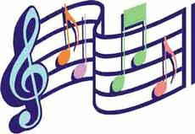

**Band 5**

Love Somebody Traditional

Hot Cross Buns Traditional

At Twilight Tyler S. Grant

Clarinet Blues Mike Story

|  |  |  |
| --- | --- | --- |
| Flute | Alto Sax | Trombone |
| Xandra Gatchel | Levin Essinger | Peighton Bowers |
| Isabella Recker | Tala Gipson | Sawyer Bowling |
| Lillian Swartzmiller | Alexis Mummert | Owen Brauen |
|  |  |  |
| Clarinet | Trumpet | Baritone |
| Adelyn Althaus | Andrew Brodman | Megan Follas |
| Keyrsten Kleman | Payton Camper |  |
| Emmerson Lee | Jacob Dawson |  |
| Kennedy Longworth | Chloe Hanefeld |  |
| Ashlyn Nulton | Micah Lemley |  |
| Hannah Reese | Lyla Schneck |  |
| Ella Roby | Payton Worcester |  |
|  |  |  |
|  |  |  |
|  |  |  |
|  |  |  |

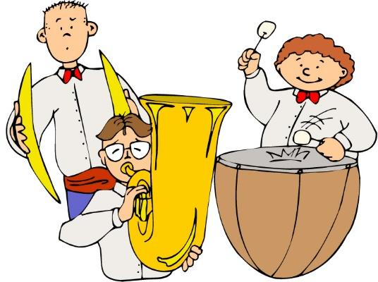

**6th Grade String Orchestra**

Medieval Dance Blason/Story

Brio Doug Spata

Celtic Dance Mark Williams

|  |  |  |
| --- | --- | --- |
| Violin 1 | Violin 2 | Viola |
| Kate Klinger | Laney Kiene | Daphne Johnston |
| Eli Lehman | Zavier Navarro | Rebekah Rehm |
| Evangeline McBrien | Wilson Steiner | Addison Schweingruber |
| Brookelynn Richardson |  |  |
| Audra Snyder | Violin 3 | Cello |
| Katie Bauman | Charlotte Burkholder | Emmitt Kidd |
|  | Aaron Ungashick | Leah Shadle |
|  |  |  |
|  |  |  |

**Junior High Orchestra**

Dragon Hunter Richard Meyer

Enchanted Forest Adrian Gordon

Finnish Folk Song Suite Traditional/Caravella

|  |  |  |
| --- | --- | --- |
| Violin I | Violin II | Violin 3 |
| Raelyn Clinger | Hailey Ballinger | Jayden Foust |
| Danielle Cross | Lauren Bowers | Kaedence Ingram |
| Maia Gearing | Elizabeth Hartzler | Liliana Liberato |
| Sophia Kauffman | Ethan Hoffman | Brianna McDonald |
| Savanna Missler | Elizabeth Honse | Elijah Nye |
| Jordyn O’Connell | Claire Phillips |  |
| Zoe Shank | Landon Sehlhorst | Cello |
| Alexis Wheeler |  | Xavier Diller |
|  |  | Makenzie Gearing |
| Bass |  | Emma Miller |
| Rory Youngpeter |  | Kaydrie Wehrly |
|  |  |  |

**High School Orchestra**

Concertino in G Elliot Del Borgo

Dragon Fire Susan H. Day

Wood Splitter Fanfare Brian Balmages

|  |  |  |
| --- | --- | --- |
| Violin I | Violin II | Viola |
| Elizabeth Frazier | Jonah Rehm | Aliana Salazar |
| Theo Andreas | Cole Bowers | Milo Combs |
| #Melina Meza | Adanna Johnstone |  |
| #Allison Burghaze | Avery Kinn | Cello |
| Ben Hartzler |  | Alyssa Speicher |
|  |  |  |
|  |  | Bass |
| *# senior* |  | Lauren Speicher |
|  |  |  |
|  |  |  |
|  |  |  |

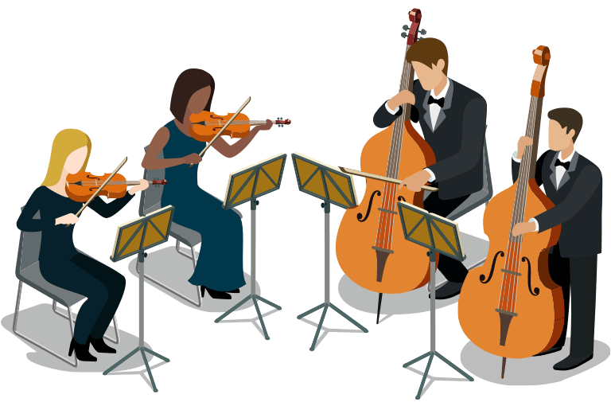

**Junior High Band**

Falcon Fanfare Brian Balmages

Flash! Brian Beck

Disney Blockbusters arr. John Higgins

Afterburn Randall Standridge

|  |  |  |
| --- | --- | --- |
|  |  |  |
| Flute | Alto Sax | Baritone |
| *Lauren Bowers | *Liliana Liberato | *Braylin Scherger |
| Ellie Hartzler | Micah Rehm |  |
| Elizabeth Honse | Ruben Spallinger | Tuba |
| Grace Lemley | Joziah Salazar | *Matthew Piehl |
| Alliyah Shisler | Kaydrie Wehrly |  |
|  |  | Percussion |
| Oboe | Trumpet | Aubrey Burkholder |
| *Avery Smith | *Asa Clingerman | Maizie Digby |
|  | Xavier Diller | Jayden Foust |
| Clarinet | June Essinger | Micah Fultz |
| Hannah Creeger | Makenna Mohr | Evan Grothause |
| *Danielle Cross |  | Elijah Nye |
| Rebecca Estell | Trombone | *Zoe Shank |
|  | Levi Fenzl | Jaiden Smith |
| French Horn | *Cody Garmatter | Trevor Smith |
| *Austin Scherger | Claire Phillips |  |
| Ava Schleeter |  |  |
|  |  |  |
|  |  | *\* section leader* |
|  |  |  |
|  |  |  |

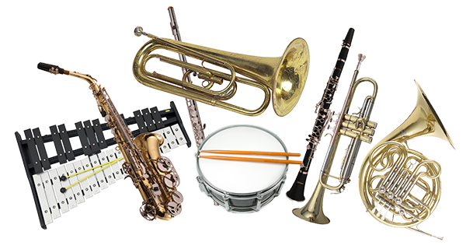

**Choir 8**

Rock the Boat arr. Greg Gilpen

Some Nights arr. Roger Emerson

At the Twist and Shout arr. Audrey Snyder

|  |  |  |
| --- | --- | --- |
| Brody Anderson | Cody Garmatter | Sydney Motter |
| Jett Blackburn | Genevieve Gatchel | Nathaniel Rayl |
| Terron Boblitt | Karlee Geesaman | Ryleigh Rex |
| Jack Brauen | Ayla Grandey | Chayse Rodabaugh |
| Hailie Bretz | Emma Green | Jordan Schweingruber |
| Noah Bricker | Adie Hanefeld | Avery Smith |
| Raelyn Clinger | Keaton Howbert | Jaiden Smith |
| Kaleigh Coffman | Luke Jebsen | Kara Snyder |
| Faith Combs | Sarah Knauss | Evan Speicher |
| Hannah Creeger | Cora Koontz | Griffin Stackhouse |
| Kaylee Dauterman | Carson Kruse | Avery Talavinia |
| Alek Davis | Avery Lamb | M’Kailah Tatum |
| Caleb Davis | Haley Lamb | Makcay Tuttle |
| Marek Donaldson | Dallas Luginbuhl | Landen Worcester |
| Quinn Eachus | Gabe Meza | Gracie Yarnell |
| June Essinger | Savana Misler | Rory Youngpeter |
| Rebecca Estell | Brooklyn Moser |  |

**Band 6**

Starfire Fanfare Randall Standridge

In Search of Yeti Kirk Vogel

Fawkes the Phoenix Williams/Story

|  |  |  |
| --- | --- | --- |
| Clarinet | Trumpet | Percussion |
| Ayanna Brodman | Isaiah Clinger | Austin Blue |
|  | Ethan Fifer | Roselove Jebsen |
| Alto Sax | Seth Hoffman | Jordan Henry |
| Coby Dailey | Elijah Lehman | Nora Mathews |
|  | Braydon McClure | Greta Myers |
| Trombone | Rebekah Rehm | Ally Stechschulte |
| Alex Dubuque | Brookelynn Richardson | Brendan Taylor |
|  | Wilson Steiner |  |
| Baritone |  |  |
| Catherine Moncada |  |  |
|  |  |  |
|  |  |  |
|  |  |  |
|  |  |  |
|  |  |  |
|  |  |  |

Thank you Bubba C’s for helping make this year’s BBQ such a success!



**Choir 6**

Supercalifragilistic… arr. Cristi Cary Miller

Green Teresa Jennings

Step By Step Teresa Jennings

Ariana Bowling – solo

Splish Splash arr. Kirby Shaw

Go Be Awesome Teresa and Paul Jennings

|  |  |  |
| --- | --- | --- |
| Willow Angel | Roselove Jebsen | Addison Schweingruber |
| Ellie Bogart | Chase Kelly | Owen Shoemaker |
| Ariana Bowling | Laney Kiene | Jake Spencer |
| Ayana Brodman | Kate Klinger | Wilson Steiner |
| Elijah Drewmore | Eli Lehman | Tate Steinmetz |
| Adam Fritsch | Karlie Lora | Bentley Thebeau |
| Tayte Giesige | Ben Lovett | Kaylee Thomas |
| Jerod Gibson | Nora Matthews | Reis Thompson |
| Blayne Hill | Greta Myers | Gracie Warren |
| Avery Hobensack | Austin Ruhlen | Amanda Zachrich |
| Caleigh Horton |  | Sophia Zemba |
|  |  |  |

