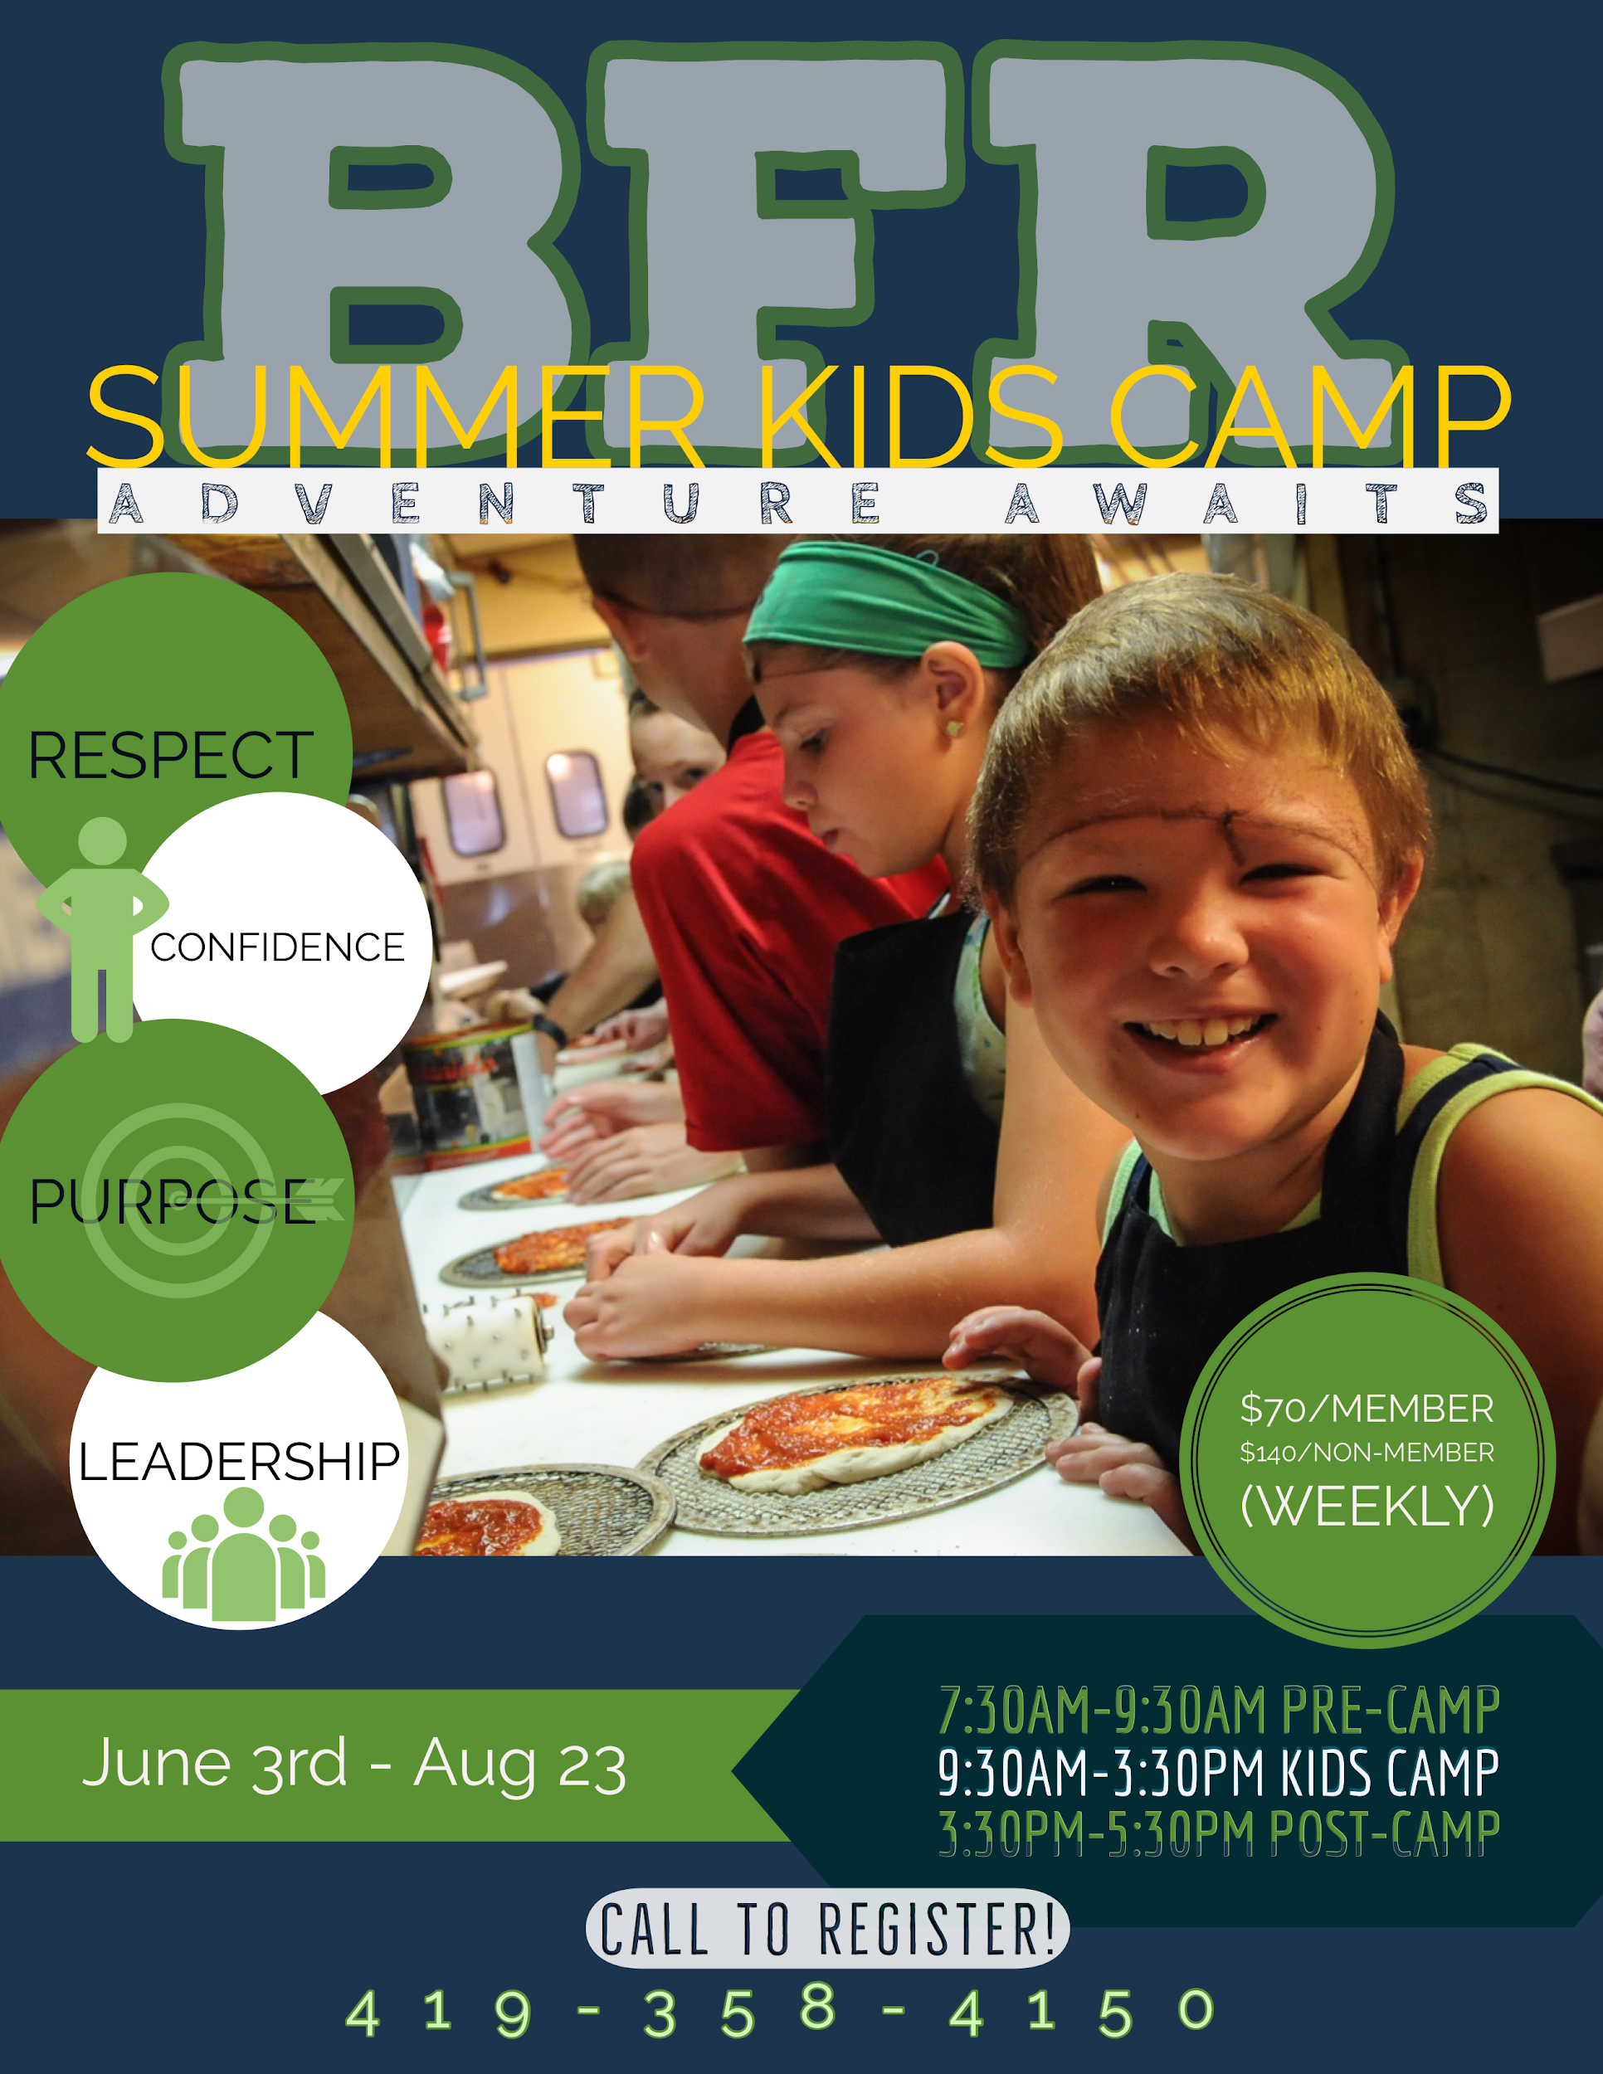
What is Traditional Summer Camp?
BFR Summer Camp is a full day experience, designed with a wide range of activities guaranteed to expand your child’s horizons. Kids have fun while making new friends, developing new skills, learning core values, building self-confidence and growing in self-reliance. Campers experience a variety of indoor and outdoor activities based around weekly themes. In addition, campers stay active in education through our daily active readers club built into each day. Join us in making this the best summer ever for your children.
Traditional Camp Hours of Operation:
Monday-Friday
7:30-9:30 AM-Pre-Camp
9:30 AM-3:30 PM-Traditional Camp
3:30-5:30 Post-Camp
Weekly Cost: Member: $70 Program Participant: $140F
Lunch: A special Thank you to Bluffton Hospital who will be providing Lunch for all campers M/W/F.
What is Preschool Camp?
Preschool Camp introduces young children to traditional day camp while their parent/guardian engages in the activities with their camper. Preschooler’s have the same fun as the big kids but stay closer to home and keep shorter hours. Activities are provided every Friday (except July 4th week camp will be held on July 2nd) from 9-11am. Each day has its own special theme and provides your camper with the experience of making new friends, developing new skills, learning core values, building self-confidence and growing in self-reliance.
Membership for all:
It is part of Bluffton Family Recreation mission that we are here for all. We provide financial assistance to individuals and families who might not otherwise be able to afford membership. Ask a staff member about financial assistance. It is easy to apply and BFR does everything we can to make membership for everyone.
Refund/Transfer Policy:
We do understand that children’s lives are busy and illnesses do occur. Registration deadlines and payments for traditional camp are always the Friday before the camp starts. If on Monday your child is unable to attend camp for that week we can transfer the funds to another week. However, there is a $10 fee that will be kept by BFR to cover the cost of equipment that has been purchased for your child. All transfers and refunds must be approved by Daniel Tinch.

Core Values: Respect, Confidence, Purpose and Leadership

Traditional Camp: (Ages 5-12)
Superheroes in training: (June 3rd-June 7th)
Ever wonder what it would be like to be a super hero? Well, now you can. Campers will experience all the thrills of being their favorite super hero through a variety of games, arts and crafts and reading. Kids will have the opportunity to create their own superhero and experience the science behind superpowers.
BFR Member: $70 Program Participant: $140
Lifehacks (June 10th-June 14th)
Campers get the opportunity to discover hands on ways to make everyday task easier and turn household items into something new. Come explore with us how to make your own sprinkler, learn how to cut a watermelon and use duct tape as a can opener.
BFR Member: $70 Program Participant: $140
Young Scientist: (June 17th-June 21st)
Come learn and discover the world of science. Campers will be hands on in conducting their own science experiments. Kids will learn how to make their slime, rock candy, perform egg experiments and conduct experiments with a real Chemist.
BFR Member: $70 Program Participant: $140
Lions, Tigers and Bears…Oh My: (June 24th-June 28th)
Campers will have the opportunity to learn and discover new things about animals including identifying a variety of animal pelts. Kids will learn through educational activities, games, arts and crafts. Quarry Farms will be our special guest of the week!
BFR Member: $70 Program Participant: $140
Fairytales and Fables: (July 1st-July 5th) No camp July 4th
Dragons, Princesses, Heroes and Princes! Campers will adventure into the stories of many fairy tales and their characters. Throughout the week campers will play Save the Princess, color roses using food coloring and build their own castle out of cardboard boxes.
BFR Member: $56 Program Participant: $112
Wilderness Week (July 8th-July 12th)
Come explore the outdoors with us! Campers will partake in activities including fishing, campfire cooking and camp ground preparation. We will have crafts such as paper plate fans to keep us cool during outside time, make your own butterfly feeder and pine cone bird feeder.
BFR Member: $70 Program Participant: $140
Warlocks/Wizards/Witches: (July 15th-July 19th)
Transform yourself this summer through the magical world of Harry Potter. Campers will make wands, play quidditch, create potions and spells. Come join us as we explore all that is magical.
Healthy Habits Camp: (July 22nd-July 26th)
Living and eating healthy has never been so much fun. Come explore your culinary skills with us as campers will create their own salsa, learn basic food and kitchen safety and learn where healthy food comes from. Make and put on your chef hats as we are hands on with our food.
BFR Member: $70 Program Participant: $140
Wacky Water Week (July 29th-Aug 2nd)
Come enjoy everything that is water. Campers will make their own slip and slide, water bed and participate in water games such as slip and slide kickball. Arts and crafts on the week will consist of erupting ice chalk paint, water filled piñatas.
BFR Member: $70 Program Participant: $140
Holidays: (Aug 5th-Aug 9th)
Ever wish that the holidays came sooner? Well, now they do! This week we will be celebrating holidays from all over the world. Come enjoy Christmas, St. Patrick’s Day, Cinco de Mayo and more. Activities include minute to win it challenges, baking holiday cookies and decorating for the festivities.
BFR Member: $70 Program Participant: $140
Reduce, Reuse, and Recycle: (Aug 12th-Aug 16th)
This week is all about being environmentally green. Campers will have the opportunity to create art projects out of materials normally destined for trash. Come join us as we discover what all is possible through recycling.
BFR Member: $70 Program Participant: $140
Fortnite Week: (Aug 19th-Aug 23rd)
Come join us for a fun week of camp style Fortnite. Games are strategy based involve building forts, team communication and raw skill. Games included will be capture the flag, nerf gun battle, dodgeball (team based and battle royale.) Come join us for this new and exciting week.
BFR Member: $70 Program Participant: $140

Pre-School Camps (Ages 3-6)
All Pre-School Camps are held Fridays 9-11 AM Except for July 2nd
Sports Bug (June 7th)
Come discover the world of sports for your preschooler. Campers will get the opportunity to learn basketball, soccer, t-ball and flag football. Campers will be taught the skills of each sport in addition to short sided games.
BFR Member: $10 Program Participant: $20
Lil Chef (June 14th)
Let’s kick it up a notch. Be creative with this hands-on day of making easy and fun snacks. Come join us as we teach campers the importance of food safety and nutrition.
BFR Member: $12 Program Participant: $24
Green Gardeners: (June 21st)
A lot of dirt doesn’t hurt! Be hands-on with nature as we discover garden creators, sow seeds and plant flowers. Each camper will have plenty of take-home greenery they made themselves.
BFR Member: $12 Program Participant: $24
Its Buggy out there! (June 28th)
We are taking the fun outside. Come explore the world of bugs with us. Campers will go on a bug scavenger hunt, make their own spider web and participate in a “worm” challenge. Gummy worms!
BFR Members: $10 Program Participant: $20
Garden Fairies: (July 2nd)
Come discover the magic of the Garden Fairy movement. Campers will have the opportunity to build their imagination and creativity through the enchanted world of Garden Fairies. Children will collect and build with natural elements for their very own take-home fairy garden.
Member: $10 Program Participant: $20
Reduce, Reuse and Recycle: (July 12th)
Saving the earth one project at a time! Campers will have the opportunity to create art projects out of materials normally destined for trash. Come join us as we discover what all is possible through recycling.
Member: $10 Program Participant: $20
Music and Rhythm: (July 19th)
Can you keep the beat? Join us as we jam into the wonderful world of music. Campers will create and play their own instruments. Instruments creations consist of DIY noise shaker, duct tape drum, rubber band guitar and water-bottle membranophone.
Member: $10 Program participant: $20
Wacky Water Day: (July 26th)
It’s time to get wet! Come stay cool with water games. Campers will enjoy a DIY slip and slide, water gun painting, float or sink experiments and much more. Be sure to wear clothing and shoes that can get wet.
Member: $10 Program Participant: $20
Color Me Messy: (Aug 2nd)
Let’s get messy! This day is designed to be a fun packed day of different colorful creations. Campers will make their own color powder, make their own colorful slime and play colorful shaving cream wiffleball.
Member: $10 Program Participant: $20
Superhero: (Aug 9th)
Ever wonder what it would be like to be a super hero? Well, now you can. Campers will experience all the thrills of being their favorite super hero through a variety of games, arts and crafts. Come experience the science behind superpowers.
Member: $10 Program Participant: $20
Wild Wilderness: (Aug 16th)
Its time to explore the outdoors. Campers will partake in tree identification, leaf coloring project and making smores in a solar powered oven. Come be a part of this exciting week.
Member: $10 Program Participant: $20
Camp Rewind: (Aug 23rd)
Let’s rewind the tape. Come enjoy the day as we revisit all of our favorite activities through out the summer. This will be a fun day packed with activities. Let’s end summer the right way with this fun day.
Member: $10 Program Participant: $20

