Newsletter
Bluffton Lions Club
www.ohiolions.org
www.blufftonlions.org
www.blufftonlionsfoundation.org

August 2019

2019-2020 Officers & Board Members:
President-Patty Navin; V.Pres-Stephanie Larcom; V.Pres-Gene Long; V. Pres-Corwin Croy; Secretary-Barbara Plaugher; Treasurer-Clair Winebar; Lion Tamer-Elaine Harris; Tail Twister-Greg Averesch; Board Members: 2 yr-Dan Diller; 2 yr-Robert Stahl; 1 yr-Tracy Steele; 1 yr-Jim Bemiller;
Immediate Past President-Christina Walton; Foundation President-Dick Ramseyer
Editor-Barbara Plaugher.

September Birthday :
Jerry Szabo 9/4 Brendon Matthews 9/22 Greg Averesch 9/28
Ed Yeager 9/28
Sepember Anniversary:
Bob Amstutz 9/2 Dan Diller 9/5 Alan Yoder 9/17
John Harris 9/29

UPCOMING EVENTS:

SEPTEMBER 2ND: Club meeting Town Hall at noon. Speaker TBA

SEPTEMBER 8TH: Handlebars Bike Club 100 Mile Ride. Lunch rest at Bluffton
Middle School. To volunteer with lunch contact Lion Greg Denecker

SEPTEMBER 9TH: Joint Club/Foundation Board meeting at Maple Crest 6:30 PM

SEPTEMBER 16TH: Club meeting Town Hall at noon. Speaker TBA

SEPTEMBER 19-21: USA/CANADA FORUM in Spokane, WA

SEPTEMBER 23 THRU OCTOBER 3: Eye screenings of kindergarten and pre-
school children. To volunteer contact Lion Barbara Plaugher

SEPTEMBER 29TH: STEPS walk for Pediatric Cancer in Spencerville.

BOARD MEETING:
Reports on net profit from the Festival of Wheels was $5,274.95. Net profit from the Ride to Remember final report is $8,350.58.
Committee assignments will be shared at the club meeting and mailed to those not attending.
October 3rd will be the Lions serving at the Community Dinner at the Seior Citizens building
November 6th will have the Dare to Dream Wine Tasting & Auction at Crimson Lane in Ada.

AUGUST 6TH MEETING: 100% attendance awards were presented to 13 - Lions Jim Bemiller, Dan Diller, Elaine Harris, Don Hostetler, Gene Long, Dennis Morrison, Patty Navin, Arliss Plaugher, Barbara Plaugher & Dick Ramseyer. Corwin Croy, John Rich and Christina Walton were not present.
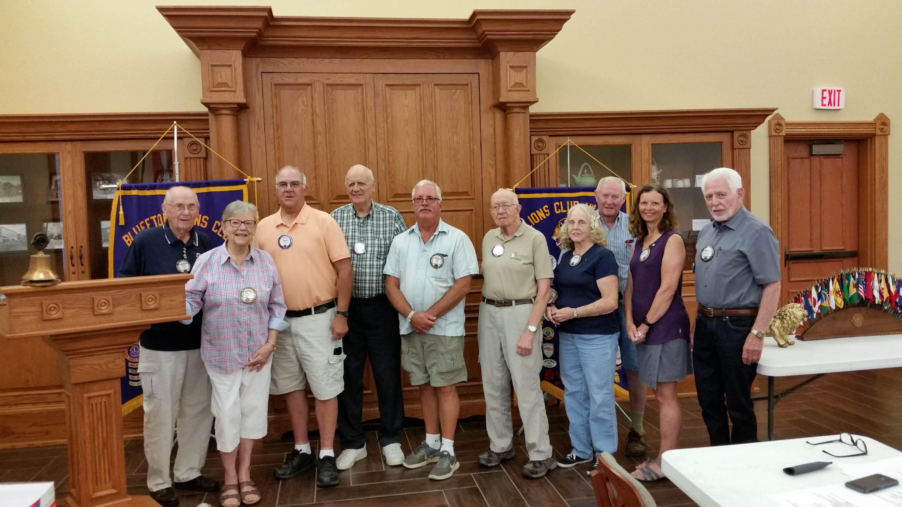
PATHWAY CONSTRUCTION:
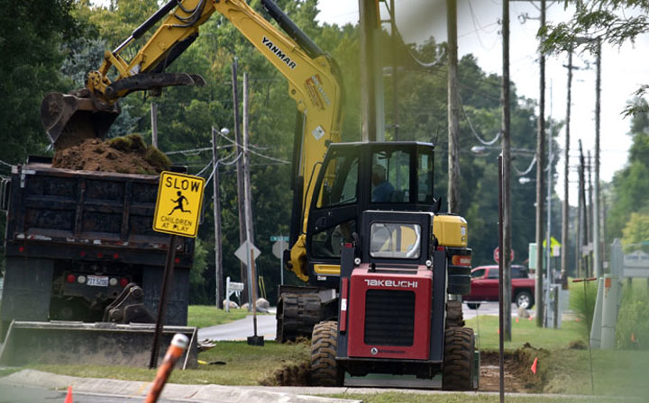
Construction has started August 19th on the new Lions Way Bentley Path…the Path connects the Lions Way Augsburger Path & travels north through the Riley Creek Subdivision along Bentley Road to Richland Drive. The contractor is Lion Don Snyder, Owner of Don Snyder Excavating LLC
AUGUST 20TH MEETING:

Bluffton Police Chief Ryan Burkholder spoke at the noon meeting of the Bluffton Lions. Chief Burkholder, a 15-year veteran of the police department, showed slides of his entire force which includes KATO the departmental dog.
He spoke of the current training of A.L.I.C.E. going into the schools and preparing the children in case of a lockdown situation.
The department had 7,246 calls for service this past year. These would include calls for medical needs, fire, civil and domestic situations, house or building checks. They also get 4 to 5 calls a week for scam issues. An informational brochure on scams can be obtained by contacting the police department:
419-358-2961 or burkholderr@bluffton-ohio.com

