Newsletter
Bluffton Lions Club
www.ohiolions.org
www.blufftonlions.org
www.blufftonlionsfoundation.org

December 2019
2019-2020 Officers & Board Members:
President-Patty Navin; V.Pres-Stephanie Larcom; V.Pres-Gene Long; V. Pres-Corwin Croy; Secretary-Barbara Plaugher; Treasurer-Clair Winebar; Lion Tamer-Elaine Harris; Tail Twister-Greg Averesch; Board Members: 2 yr-Dan Diller; 2 yr-Robert Stahl; 1 yr-Tracy Steele; 1 yr-Jim Bemiller;
Immediate Past President-Christina Walton; Foundation President-Dick Ramseyer
Editor-Barbara Plaugher

January Birthday :
Tracy Steele 1/8 Barbara Plaugher 1/11 Greg Denecker 1/14 Don Hostetler 1/14 Ron Headings 1/15 Arliss Plaugher 1/15 Alan Yoder 1/22 Dick McGarrity 1/29

UPCOMING EVENTS:

JANUARY 7TH: Club meeting noon at the Town Hall. Speaker will be Kim
Simonds, physician liason to Dr Adam, urologist.

JANUARY 14TH: Board meeting 6:30 pm Town Hall

JANUARY 21ST: Club meeting noon at the Town Hall. This will be a
Business meeting.

50/50 Drawing for November 2019:
$100 Riley Larcom sold by Stephanie Larcom
$50 Denny Smith sold by Stephanie Larcom
$30 David Urich sold by John Rich
$20 Luke Thiede sold by Patty Navin

BOARD REPORT: A resignation letter from Omar Khokhar was accepted by the board. Omar is no longer associated with the Quality Inn.
New member Ryan DeMarco was accepted by the board.
Donations for Lions Clubs International Foundation $1,000; Ohio Lions Foundation $400; Ohio Lions Eye Research $100; Lions International Relations $200; Ohio Sight & Hearing $200 checks to be paid.
Local donations the board suggested that we have a personal presentation and note in the local paper.
A donation of $200 to Andrew’s House was approved by the board.

DUES ALONG WITH 50/50 RAFFLE TICKETS AND MONEY--DUE THIS MONTH
PLEASE FORWARD THIS TO: Lion Barbara Plaugher, 62 Anna Circle, Bluffton, 45817
NEW MEMBER:
Jean Cook raised in Pandora, graduated from OSU and worked in healthcare in a variety of capacities locally, with Ohio Department of Health and OSU Medical Center. Jean returned to the area to care for her ailing mother a few years ago. She has a son in Dayton and daughter in Grandview. She has been volunteering with the Bluffton Lions and enjoys helping with the club’s activities.

CHRISTMAS SERVICE PROJECT:
Received from the Bluffton Community Assistance Corporation…. I extend my thanks for your generous contribution of food items, gift cards and money. This Christmas, 59 families will participate in the Adopt A Family program. On December 3rd the Lions assembled 40 bags to be given out to the adoptees. Because of the generosity of our local churches and the help of the Bluffton University Baseball team 19 more bags are being assembled so that every adopted family receives a gift bag. Lion Ed Yeager
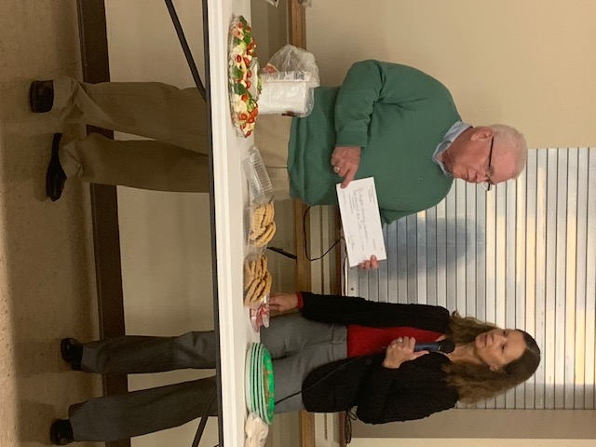
President Lion Patty Navin of the Bluffton Lions Club presented a check of $500 to Lion Ed Yeager, the director of Bluffton Community Assistance for the Food Bank, as it is commonly known. This was during the club’s service project night on December 3rd.

President Navin presents Lion Ed Yeager with the Melvin Jones Fellowship award. Bluffton Lions club donated to LCIF through the Melvin Jones Fellowship Program thus giving the Bluffton Lions an opportunity to award this prestigious award to Lion Yeager. This award is the highest award a lion can receive in recognition of his commitment to humanitarian work and service to the community.
