Newsletter
Bluffton Lions Club
www.ohiolions.org
www.blufftonlions.org
www.blufftonlionsfoundation.org

November 2014
2014-2015 Officers & Board Members:
President-Stephanie Larcom; V. Pres-Mitch Kingsley; V. Pres-John Rich; Secretary-Barbara Plaugher; Treasurer-Lowell Hostetler; Lion Tamer-Arliss Plaugher; Tail Twister-Greg Averesch; Board Members: 1 yr-Mark Alliman; 2 yr-Jim Bemiller; Foundation President-Dick Ramseyer; Editor-Barbara Plaugher.

December Birthday:
Jerry Lewis 12/1 Gordon Diller 12/6 Doug Luginbill 12/6
Sue Shields 12/12 Charles Amstutz 12/21 Gene Long 12/22
Robert Amstutz 12/25
December Anniversary:
Gordon Diller 12/21 Lowell Hostetler 12/21 Ed Yeager 12/27
Brendon Matthews 12/29

UPCOMING EVENTS:
November 29th: Blaze of Lights Chicken Bar-B-Q and parade. Sign up to help @ the BBQ or pass candy out during the parade.
December 2nd: MARK YOUR CALENDAR for the Christmas Social at 6:00 PM. Location First Mennonite Church Bluffton. Henry’s will cater our meal for $15.00/plate. Program will be guitarist, Jim Boedicker, providing entertainment and music from folk to classical. It will be an enjoyable evening. Reservations needed, check with Lion John Rich.

BOARD REPORT:
Discussion on the wine tasting event. Around $13,000 was raised for the pathway project. A planning meeting will begin on another similar event in 2015. Chicken Barbeque ticket sales are ongoing. Additional dinners will be sold at a tent located next to the Buffton News.

NOVEMBER 5TH FUND RAISING:

The Bluffton Lions Foundation hosted, on Wednesday evening November 5, 2014, the Dare to Dream Wine Tasting & Auction social at the Sycamore Lake Winery…the enjoyable event featured lots of socializing, free appetizers, music, three samples of wine, silent & live auctions, 50/50 and Ipad drawings… proceeds were used to support the Bluffton Bike & Pedestrian Pathway Project. 144 individuals purchase tickets for the event which raised over $13,000 for the Pathway project.
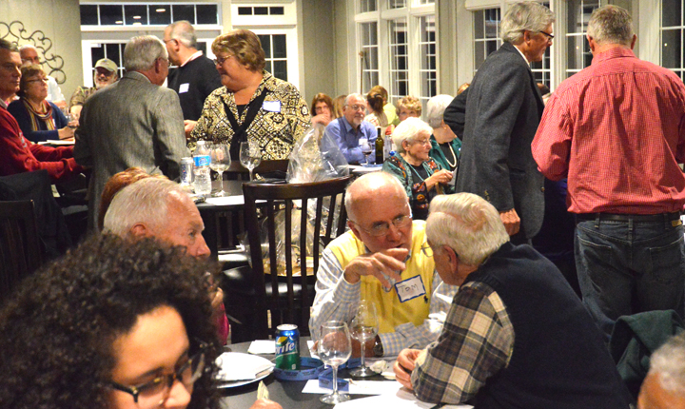
NOVEMBER 4TH MEETING:
LCIF focuses on 4 areas: Sight Related, Disaster, Humanitarian and Youth. The goal of our organization is “No More Preventable Blindness” by 2020. To date there have been over $100 million contributed to disaster relief and $800 million in grants provided by LCIF. Over 600 eye clinics have been built, over 400,000 eye surgeries provided and over 600,000 health workers trained in underdeveloped countries. LCIF partnered with the Bill & Melinda Gates Foundation to eradicate measles worldwide, as measles kills 400 persons/day and a vaccine costs only $1 each. Locally grants have been provided recently for handicap playground equipment in Wauseon and a grant has been applied for the Lima Sight Center. These were some of the statistics discussed at our November 4th meeting. The Bluffton Lions Club donates to LCIF and this is where your money goes.

NOVEMBER 18TH MEETING:

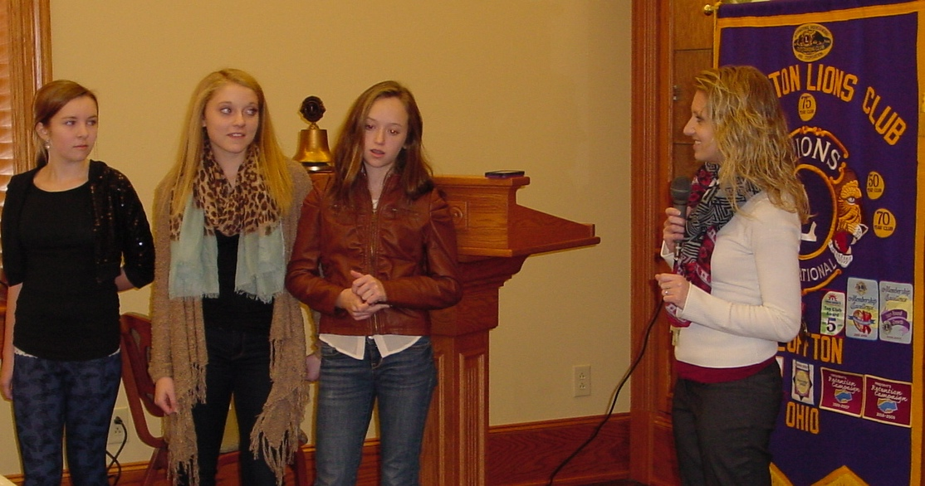
Peace Poster Winners:
Theme was “Peace, Love and Understanding”

1st place – Danielle Novak
2nd place – Kylee Staley
3rd place – Bailey Edwards

Nicole Anderson is the art teacher for the Bluffton Middle School

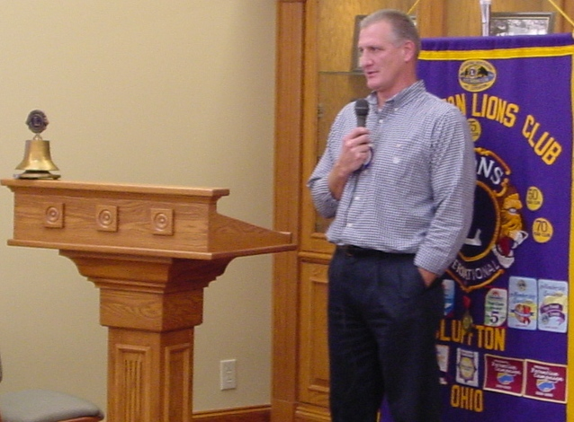
Lion Jeff Joseph was the speaker at our November 18th meeting. He is the Site Manager of Tower International here in Bluffton. He shared information on locations all over the world where Tower has plants, the types of parts that are stamped at the Bluffton plant, information on the equipment used, the quality and statistics involved to grow and maintain the plant. He talked about the growth of the plant that has evolved, the employees, and the vehicles using the stamped parts. Very informative presentation.

