Ways to Participate

Register a Team- Show your support the Relay for HOPE by registering your friends, church members or family as a team! Your team will be encouraged to raise money and schedule walkers.

Purchase BBQ Tickets- Tickets for the dinner will cost $8.00 and are available from any Committee member, Village Cut & Curl, or Polished.

Support the Relay by Walking- Stop out at the event, walk a few laps, and make a donation or just watch the great entertainment.

Order a Luminary- remember those who have died or celebrate a survivor by completing an order form. Luminaries will be lighted for the Remembrance Service.
If you’d like a luminary and don’t know where to find the forms, they are available at Village Cut & Curl or Polished or call Kathy Boehm at 419-348-0872. They will also be sold at the Relay event until 8:30PM on Friday, June 24th.

Register for the 5K Glow Run
A new event for 2016 is scheduled
for Friday, June 24 at 10:30 pm;
Information on other page

Bid on Silent and Live Auction
Homemade pies, hand-painted
chairs, plus lots of special items will
be auctioned that night.

Come support Trinity Lutheran
Church’s Food Booth. They have
sandwiches, chips and drinks to
purchase and be sure and buy
some tickets for their Samsung
Galaxy Tab A. Drawing will be at
9:30PM on Friday, June 24th
during the Relay.

Popcorn will be available from
Village Cut & Curl Team.

Ice cream will be available from
the Emmanuel United Church of
Christ’s team.

Cotton Candy will be available
from the Rack Pack Team.

Fire Fighters – Come join
numerous fire departments walking
a lap at 10:00PM together wearing
all your turnout gear.

Games for the kids – there will be
kids games from 6:30 to 8:00PM by
BFR and some of the teams have
games set up, too.
Our theme for this year is Courage. Shirts can be
Purchased
At
Village Cut & Curl or Polished
For $10 or $12 each
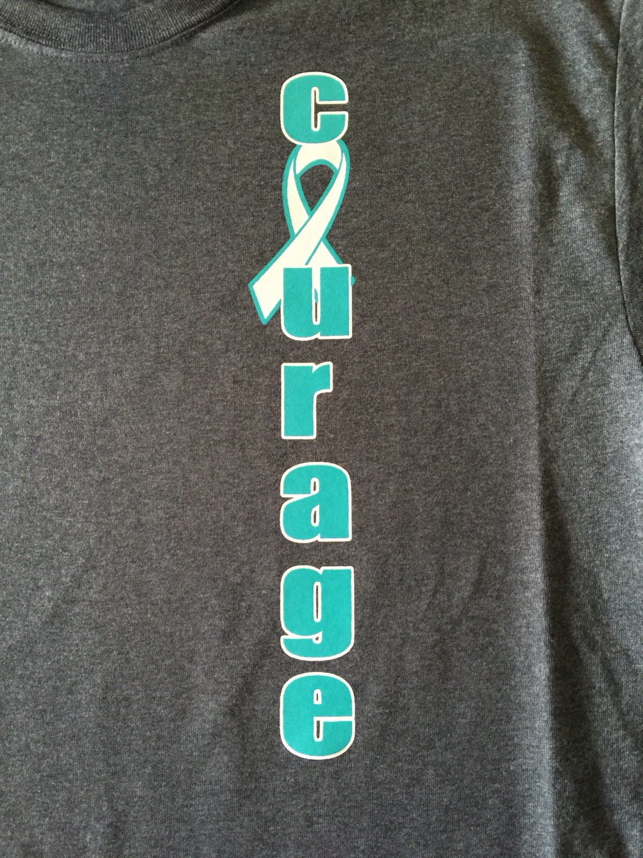
There will be valet parking.

New teams are
WELCOME!
Contact Lynda Best
(419-358-7593) or
Any committee member

Like us on Facebook at
BlufftonOhioRelayForLife

June 24-25, 2016
BFR Sports & Fitness
215 Snider Road

2016 Schedule
2:00-8:30PM Luminaries available for purchase
At tent along BFR sidewalk
4:30-6:30PM Drive thru or dine in barbecue
5:00PM Survivors Meal
5:00PM Katie Hohenbrink-entertainment
5:00-9:30PM Silent Auction inside BFR
By Trinity Lutheran Church
5:30PM Pie judging inside BFR
6:15PM Presentation of colors
National Anthem
By Courtney Mclaughling
Invocation
Opening remarks
Survivor Lap
Caregiver Lap
Team Lap
6:30-8:00PM Children games by BFR
6:30-??? Concession Stand inside BFR
By Trinity Lutheran Church
6:30-7:30PM Music by John Butler
7:30-8:00PM Flag City Cloggers
7:45PM Pie Auction by
Trinity Lutheran Church inside BFR
8:00PM Quarter lap
8:00-9:00PM Music by the Praise Team
From Bethel Church of Christ
9:00PM Luminary Service
NO WALKING ON TRACK
9:30PM Memory lap in silence
9:30PM Registration for the 5K Glow Run
At the table at BFR front doors
9:30PM End of Silent Auction
10:00PM Fireman’s Lap
10:30PM 5K Glow Run
11:00PM Music by Nick Nowlan
Midnight Pizza inside BFR
1:00AM Hat or wild hairdo lap
2:00AM Scavenger Hunt
3:00AM Robe, PJs, slippers lap
4:00AM Dance around the track
5:00AM Crazy socks lap
5:30-6:30AM Breakfast by the Rack Pack
6:30AM-8:00AM Clean up
8:00AM Closing ceremony
These brochures have been printed by
St Rita’s Hospital in Lima, Ohio.
NEW THIS YEAR
A 5K GLOW RUN

June 24 at 10:30PM
starting and finishing at BFR.

Registration starts at 9:30 PM
Registration: $20.00 – includes a shirt
if registered by June 5th
After June 6th - $25.00
All proceeds go to
Bluffton Relay for Life

Door prizes and 50/50
Make checks payable to
Bluffton for Hope

Register online at: www.ative.com
OR email Lynda Best at
Lbest43@embarqmail.com

Forms are also available at
Village Cut & Curl
Or call
Lynda Best 419-296-2790

Who is planning the
Bluffton for COURAGE Relay?

A dedicated group meets all year-
long to prepare for the June event.

Volunteers are from several
communities surrounding Bluffton
AND all have been directly touched
by the disease of Cancer.

Lynda Best Chairperson
Kathy Boehm Vice Chairman
Edna Conkling Entertainment
Kathy & Don Boehm Luminaries
Diane Huber Survivor meal
Shelly Neeley Survivor meal
Lynda Best 5K Glow run/walk
Edna Conkling 5K Glow run/walk
Jerry Burkholder
Roger Brodman
John Spaeth
Sherree Stratton
Sherry Stratton

Bluffton Area
Relay For Hope
An event to
Fight Cancer
There

