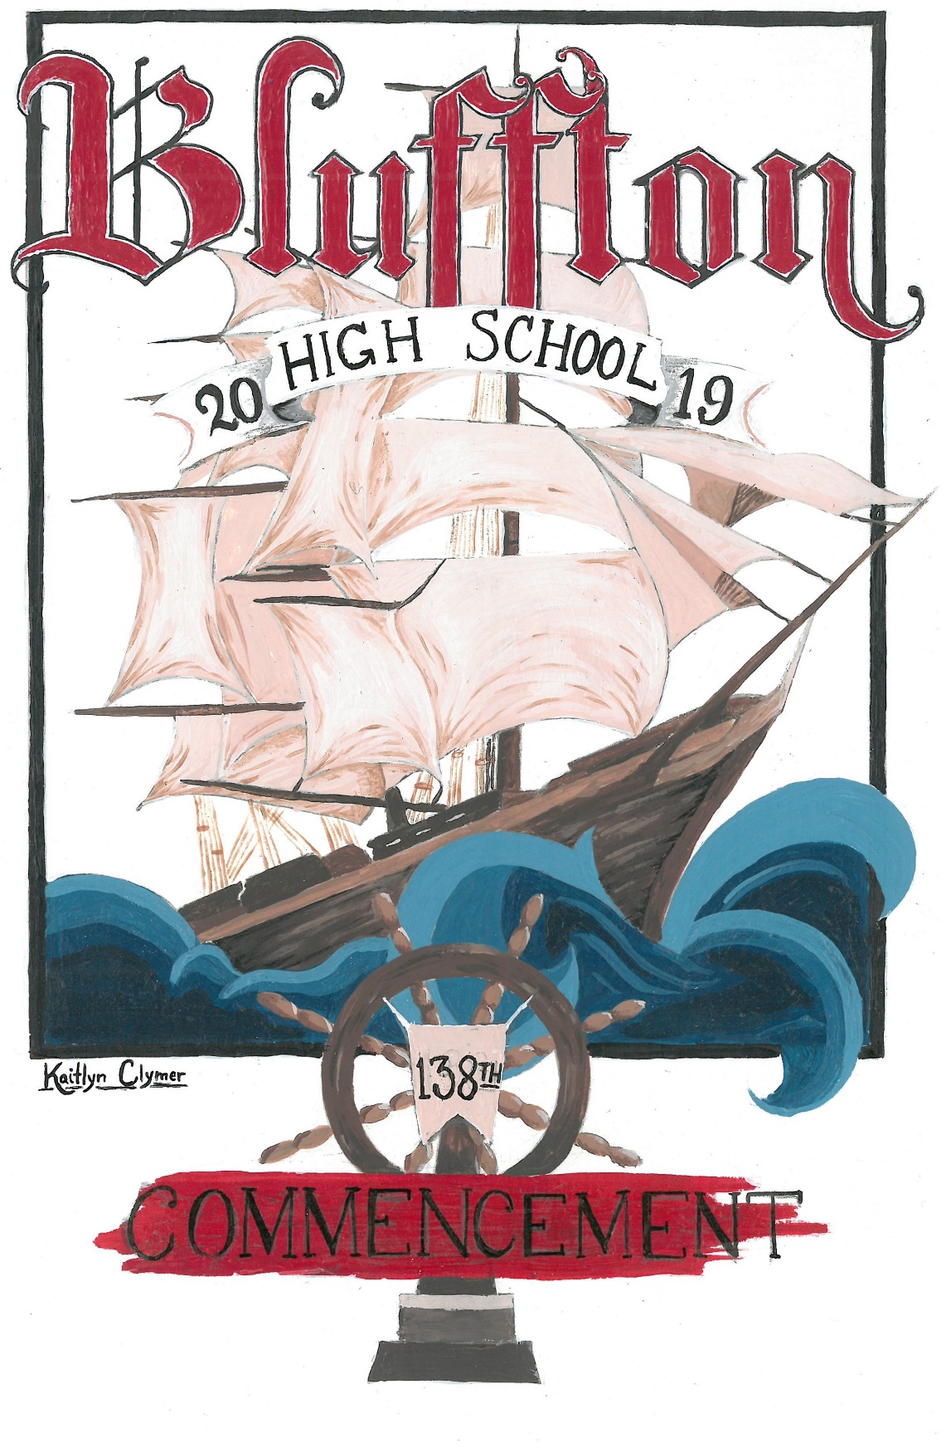

**BLUFFTON HIGH SCHOOL CLASS OF 2019**

|  |  |  |  |
| --- | --- | --- | --- |
| Noah Neely Adams *~ |  |  | Amelia Grace Mitchell *~V |
| Jason Allen Althaus |  |  | Jesse Lamoin Montel ~ |
| Olivia Beth Amstutz *~ |  |  | Shyanne Elizabeth Mortimer *~ |
| Seth Wiebe Andreas *~V |  |  | DeAndre Eric Nassar ~ |
| Mason Alexander Ault ~ |  |  | Tyler Trey Niles |
| Raychel Marie Avila *~ |  |  | Morgan Rayne Nusbaum ~ |
| Brett Mitchell Basinger |  |  | Arielle Elizabeth Shi'Vai O'Neal |
| Shon Michael Beach |  |  | Tanner Reed Pinks |
| Andrew Roland Bertka |  |  | Kaitlyn Brooke Prater *~V |
| Lacey Nichole Boyle |  |  | Andrew Robert Raeburn |
| Madeline Grace Burghaze *~V |  |  | Logan Edward Rhodes ~ |
| Sarah Ann Cartwright |  |  | Austin Michael Roberts |
| Dakoda Matthew Clymer |  |  | Averey Leigh Rumer *~ |
| Kaitlyn Rose Clymer |  |  | Isaiah Bryce Schwab |
| Ellen Kennedy Coughlan *~V |  |  | Jonathan Blake Schwab |
| Rhett Aaron Donaldson *~ V |  |  | Lily Ellen Shadle *~V |
| Ashley Renee Eachus *~ |  |  | Trey Matthew Shisler |
| Kathleen Renee Edelbrock |  |  | Jordan Paul Siefer |
| Bailey Anne Edwards |  |  | Ameiri Aubree Siferd |
| Jacey Elizabeth Mullholand Gardner |  |  | Amanda Leigh Speicher *~V |
| Autumn Anne Gesler |  |  | Kylee Shea Staley *~ |
| Kaytlin Rose Hough |  |  | Jackson David Steinmetz *~ s |
| Alexandra Nicole Hover |  |  | Isaac Yoder Strahan *~ |
| D Jackson Howell |  |  | Korey Lynn Strahm |
| Emma Lane Klinger |  |  | Makenna Sue Swaney |
| Alivia Paige-Katherine Koenig |  |  | Derek James Swartzlander *~ |
| Jaelyn Elissa Lancaster |  |  | Benjamin Alexander Theis |
| Alexis Brooke Lehman |  |  | Kaitlin Tiana Patrece Thurmond |
| Kailey Michele Mault |  |  | Chad Michael Veit |
| Victoria Anne May |  |  | Hannah Renee Yost *~V |
| Caleb Manuel Mikesell *~ |  |  | Luke Brian Young *~ |
| Mara Drue Minnig |  |  | Caitlyn Rainna Renea Zimmerman |
|  |  |  |  |

V Valedictorian s Salutatorian * Honor Student ~ Diploma w/ honors

**PROGRAM**

**~Processional**  High School Band

**“Pomp and Circumstance”**

By James D. Ployhar

David B. Sycks, Director

**\*The National Anthem** High School Band

**Welcome** Hannah Yost

**Introduction**  Dr. Greg Denecker, Superintendent

**Speech**  Katie Prater

**Music**  High School Band

**“To Create a Voice”**

By Carol Brittin Chambers

David B. Sycks, Director

**Music** Concert Choir & Symphonic Choir

**“Remember Me” from the movie “Coco”**

Arrangement by Roger Emerson

Kara Zink, Director

**Senior Song** Senior Choir Members

**“On My Way”**

By Phil Collins

**Speech**  Seth Andreas

**Introduction of Class** Mr. Mike Minnig, Principal

**Presentation of Diplomas** Mr. Wes Klinger, School Board President

**~Recessional** High School Band

**“Fanfare and Recessional”**

by James D. Ployhar

David B. Sycks, Director

**Apollo Representative**  Tara Shepherd

**Ushers/Programs:** Junior Class Officers

Nephi Peralta, President; Luke Denecker, Vice President

Kaitlyn Rieman, Secretary; Sophia Smucker, Treasurer

**\* Please stand ~ Please remain seated**

*In keeping with the dignity of the occasion,*

*please limit your congratulations to applause.*

**Please silence your cell phones and refrain from flash photography.**

**ADMINISTRATION**

|  |  |
| --- | --- |
| Superintendent | Dr. Greg Denecker |
| High School Principal | Mr. Mike Minnig |

**BOARD OF EDUCATION AND SECRETARIES**

|  |  |
| --- | --- |
| President | Mr. Wes Klinger |
| Vice President | Mr. Brad Fruchey |
| Member | Mr. Ken Lugibihl |
| Member | Mr. Jeremy Scoles |
| Member | Mrs. Renee Smith |
| Treasurer | Mrs. Paula Parish |
| Board Secretary | Mrs. Julie Steiner |
| High School Secretary | Mrs. Julie Oberly |
| High School Counselor Secretary | Mrs. Mary Hoffer |

**HIGH SCHOOL FACULTY**

Dr. Elizabeth Smith, School Counselor

|  |  |
| --- | --- |
| Miss Kate Bauer | Mr. Kevin King |
| Mr. Todd Boblitt | Mrs. Ashley Knowlton |
| Mrs. Rachel Diller | Mrs. Rachael Lewis |
| Miss Jamie Erford | Ms. Michaeline Lovell |
| Mrs. Karen Falk | Mrs. Jessica Mayberry |
| Miss Makenna Fox | Mrs. Ashley Nickles |
| Mrs. Vickie Garmon | Mr. Kevin O’Rear |
| Mr. John George | Mr. Nick Rackley |
| Mr. Alex Hanna | Mrs. Pam Riffle |
| Mr. Mardy Herr | Mr. Mason Roth |
| Mrs. Brigette Hoff | Mr. David Sycks |
| Mr. Scott Hoff | Mrs. Kara Zink |
| Miss Addie Kiene |  |

**Class Colors…………………………………………...…………**Red & White

**Class Flower ………………………………………..……………………**Rose

**SENIOR CLASS MOTTO**

“Although no one can go back and a make a brand new start, anyone can start from now and make a brand new ending.” – Carl Bard

**SENIOR CLASS OFFICERS**

President- Luke Young

Vice President-Katie Prater

Secretary-Tanner Pinks

Treasurer-Logan Rhodes

**FUTURE PLANS OF THE CLASS OF 2019**

|  |  |  |
| --- | --- | --- |
| Noah Adams | University of Iowa | Undecided |
| Jason Althaus | The Ohio State University ATI | Plant and Soil Management |
| Olivia Amstutz | Cleveland School of Cannabis | Horticulture & Medical Application |
| Seth Andreas | Eastern Mennonite University | Mathematics & Computer Science |
| Mason Ault | Ohio University | Music Prod. & Recording Industry |
| Raychel Avila | Miami University | Psychology & Pre-med |
| Brett Basinger | Rhodes State College | Business Administration |
| Shon Beach | Undecided |  |
| Andrew Bertka | University of Northwestern Ohio | Sports Marketing & Management |
| Lacey Boyle | Undecided |  |
| Madeline Burghaze | Indiana Wesleyan University | Biology (Pre-Med) |
| Sarah Cartwright | Rhodes State College | Medical Administrative Assistant |
| Dakoda Clymer | University of Northwestern Ohio | Business Administration |
| Kaitlyn Clymer | Undecided |  |
| Kennedy Coughlan | Northern Michigan University | Biology (Zoology) |
| Rhett Donaldson | Ohio University | Biological Sciences (Pre-Med) |
| Ashley Eachus | Taylor University | Elementary Education |
| Kathleen Edelbrock | Owens Community College | Culinary |
| Bailey Edwards | Rhodes State College | Radiologic Technology |
| Jacey Gardner | Work Force |  |
| Autumn Gesler | Shawnee State University | Animation |
| Kaytlin Hough | Undecided |  |
| Alexandra Hover | Apollo Career Center | Nursing/LPN |
| Jack Howell | Workforce |  |
| Emma Klinger | Rhodes State College | Physical Therapy Assistant |
| Alivia Koenig | Urbana University | Sports Management |
| Jaelyn Lancaster | Work Force | Cosmetology |
| Alexis Lehman | Work Force |  |
| Kailey Mault | Rhodes State College | Radiology |
| Victoria May | Undecided |  |
| Caleb Mikesell | Bluffton University | Early Childhood Education |
| Mara Minnig | Bowling Green State University | Pre-Vet |
| Amelia Mitchell | Xavier University | Biomedical Sciences (Pre-Med) |
| Jesse Montel | Ohio Northern University | Computer Science |
| Shyanne Mortimer | Manchester University | Bio-Chemistry (Pre-Med) |
| DeAndre Nassar | Cleveland State University | Criminology |
| Tyler Niles | Bluffton University | Dietetics/Human Nutrition |
| Morgan Nusbaum | Northern Michigan University | Biology (Pre-Vet) |
| Arielle O’Neal | Manchester University | Pre-Occupational Therapy |
| Tanner Pinks | Bowling Green State University | Architecture |
| Katie Prater | Ohio Northern University | Pharmacy |
| Andrew Raeburn | Deferred Graduation Program |  |
| Logan Rhodes | Ohio Northern University | Supply Chain & Actuary Sciences |
| Austin Roberts | Workforce |  |
| Averey Rumer | Mount Carmel College of Nursing | Nursing |
| Isaiah Schwab | United States Marine Corp | Combat Engineer |
| Jonathan Schwab | Workforce |  |
| Lily Shadle | Ohio Northern University | Pharmacy |
| Trey Shisler | Cleveland School of Cannabis | Horticulture |
| Jordan Siefer | United States Navy | Sonar Technician |
| Ameiri Siferd | The Ohio State University Lima | Social Work |
| Amanda Speicher | Indiana Wesleyan University | Music Education |
| Kylee Staley | Rhodes State College | Nursing |

**FUTURE PLANS OF THE CLASS OF 2019**

|  |  |  |
| --- | --- | --- |
| Jackson Steinmetz | Goshen College | Film Production & Communications |
| Isaac Strahan | Ohio Northern University | Mechanical Engineering |
| Korey Strahm | Workforce |  |
| Makenna Swaney | University of Cincinnati | Interior Design |
| Derek Swartzlander | Xavier University | Accounting |
| Ben Theis | Ohio University | Computer Science |
| Kaitlin Thurmond | Rhodes State College | Early Childhood Education |
| Chad Veit | University of West Florida | Nursing/Journalism |
| Hannah Yost | Cedarville University | Broadcasting and Digital Media |
| Luke Young | Cedarville University | Accounting and Finance |
| Caitlyn Zimmerman | Wright State University Lake Campus | Earth and Environmental Science |

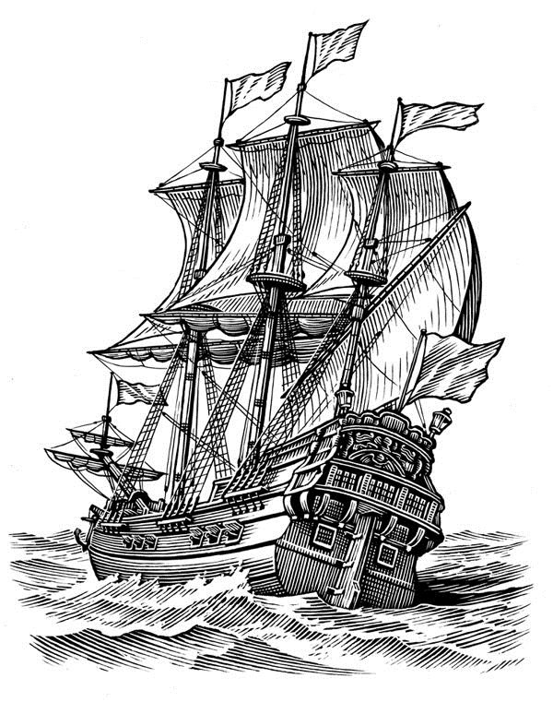

***Congratulations and good luck Class of 2019!!***

***“Have no fear of new horizons. Set sails, leave the***

***safe harbor, and let yourself carry away with***

***the wind straight into the future.”***

***-J. Lanford***