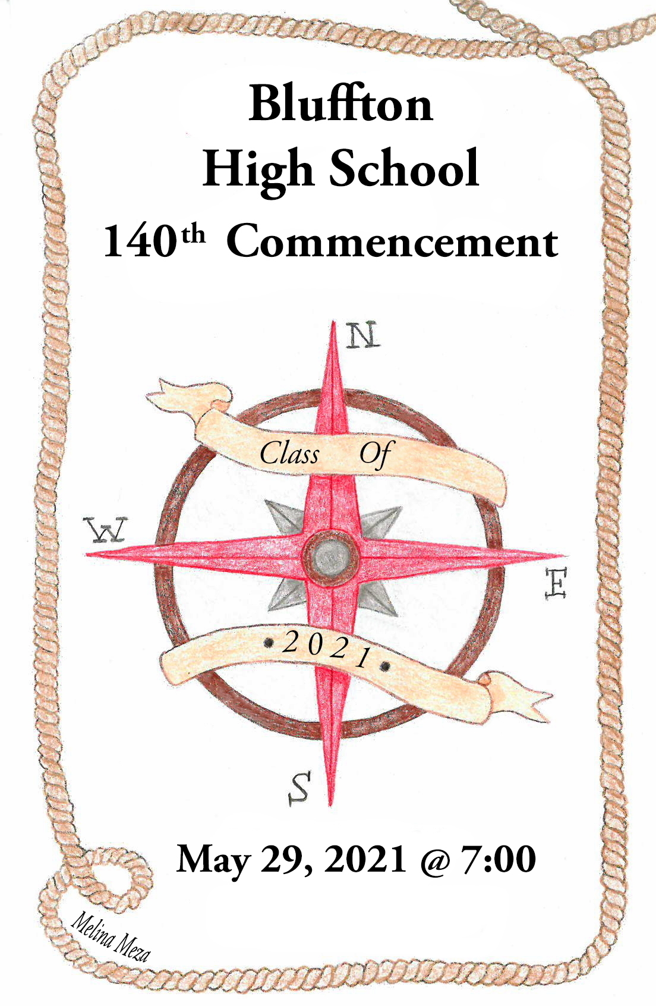

BLUFFTON HIGH SCHOOL CLASS OF 2021
Cierra Breann Ackerman ~
Isabella Rose Angel ~ * V
Asher Daniel Antrim ~ *
Hunter Martin Augsburger ~ *
Olivia Marguerite Barnes ~
Brien Philip Basinger
Isabella Kate Basinger ~
Tré Russell Bender
Cora Grace Bischoff ~
Jonah Adam Blackburn ~ * V
Jarvae Maryella Boughan *
Andrea Louise Bourassa *
Elizabeth Claire Bourassa ~
Allison Paige Burghaze ~ *
Derek Michael Carr-Lane
Elijah Joel Conley ~ *
Lauren Nicole Conrad
Charles Stephen Crow
Erin McKenzie Cunningham *
Alec Wade Deardorff
Anna Elizabeth Deitering
Simon Robert Derstine ~ * V
Abril Alison Diaz Valdiviezo ~ * S
Louisa Mikayla Dunlap *
Carter Zane Dyar
Jack Francis Edwards
Benjamin Scott Eiden ~ *
Nicholas Alan Essinger
Adam Shane Fredritz ~ * V
Laykin Lynn Garmatter ~ *
Haleigh Ann Gatchel ~ * V
Victoria Annamarie Gerschutz
Brandon Matthew Good ~
Wyatt Timothy Gossard
Louis Michael Graham ~
Hunter Dean Michael Hageman
Conrad Reese Hannum
Makenna Lynn Hauenstein
Rebekah Carmel Hoff ~ * V
Ellie Jo Hoffman ~ *
Levi Dean Hohenbrink ~ *
Christian Jakob Hosler
Lydia Renee Huber
Nicholas Allen Jebsen ~ * V

Kennedi Shawn Jordan ~ *
Alexcia Vivian Justus ~
Brenna Nicole Kindle ~ * V
Tayton Andrew Kleman ~ *
Grant Wesley Klinger ~
Connor Owen Lee
Eli Timothy Lemley ~
Pearl Ann Lewandowski ~ *
Carlin Eugene Mathewson
Kylie Amber Mathewson
Logan Michael Mathewson
Clara Hope Matthews ~ *
Levi Thomas McClain
Ayden Carl McDougle
Joshua Russell Mehaffie ~ * V
Joshua Michael Meyer ~ * V
Melina Ymazool Meza ~ * V
Thaddeus Alexander Mittendorf ~ * V
Grace August Myers ~ * V
Gabriel Avery Neuenschwander
Tayler Eileen Nowak-Valentine
Eden Timothy Nygaard ~ *
Collin Mathew Oglesbee ~ *
Zavier Alexander La’Derian O’Neal
Malachi Cayden Pahl
Nathan David Parker
Trent Michael Pearson
Lauren Elizabeth Rhodes ~
Alexi Grace Rieman *
Jonathan Charles Schriner ~
Taylor Christine Schwab ~ *
Olivia Jean Setzer
Tyson Jacob Shutler
Daniel Aaron Siders
Lucas Monforte Silva
Julia Elizabeth Smallcombe ~ * V
Celia Kay Smith ~ *
Olivia Ellene Spallinger ~ *
Jeremy John Sturgeon II
Joshua Bryan Taylor
Kayla Renee VanAtta
Justice Lynn West
Mason Ray Wingate
Elizabeth Samantha Allison Hope Wright ~ * V

V Valedictorian s Salutatorian * Honor Diploma ~ Diploma w/ honors

PROGRAM
~Processional High School Band
“Pomp and Circumstance”
By James D. Ployhar
David B. Sycks, Director
*The National Anthem High School Band
Welcome Nick Jebsen
Introduction Dr. Greg Denecker, Superintendent
Speech Jonah Blackburn
Music High School Band
“Prestissimo”
By Karl King, arranged by James Swearingen
David B. Sycks, Director

Senior Song Senior Choir Members
“Stand in the Light”
Written by Lauren Christy/Stephen Moccio

Speech Julia Smallcombe
Introduction of Class Mr. Mike Minnig, Principal
Presentation of Diplomas Mr.Wesley Klinger, School Board President
~Recessional High School Band
“Fanfare and Recessional”
by James D. Ployhar
David B. Sycks, Director
Apollo Representative Tasha Sheipline
Ushers/Programs: Junior Class Officers

Dylan Hohenbrink, President; Libby Frazier, Vice President
Kiera Rieman, Secretary; Jordyn Garmatter, Treasurer

* Please stand ~ Please remain seated
In keeping with the dignity of the occasion,
please limit your congratulations to applause.

Please silence your cell phones and refrain from flash photography.

ADMINISTRATION

Superintendent | Dr. Greg Denecker
High School Principal | Mr. Mike Minnig

BOARD OF EDUCATION AND SECRETARIES

President | Mr. Wesley Klinger
Vice President | Mr. Larry Hoffman
Member | Mr. Brad Dailey
Member | Mr. Ken Lugibihl
Member | Mr. Jeremy Scoles
Treasurer | Mrs. Paula Parish
Board Secretary | Mrs. Julie Steiner
High School Secretary | Mrs. Julie Oberly
High School Counselor Secretary | Mrs. Mary Hoffer

HIGH SCHOOL FACULTY
Dr. Elizabeth Smith, School Counselor

Miss Kate Bauer | Mrs. Ashley Knowlton
Mr. Todd Boblitt | Mr. Kasey Krendl
Mr. Jason Diller | Mrs. Rachael Lewis
Mrs. Rachel Diller | Ms. Michaeline Lovell
Miss Jamie Erford | Mrs. Jessica Mayberry
Mrs. Karen Falk | Mrs. Ashley Nickles
Mrs. Vickie Garmon | Mr. Kevin O’Rear
Mr. Alex Hanna | Mr. Nick Rackley
Mr. Mardy Herr | Mrs. Pam Riffle
Mrs. Brigette Hoff | Mr. Mason Roth
Mr. Scott Hoff | Mr. David Sycks
Miss Addie Kiene | Mrs. Kara Zink
Mr. Kevin King

Class Colors…………………………………………...…………Red & White
Class Flower ………………………………………..……………………Rose

SENIOR CLASS MOTTO

“To accomplish great things, we must not only act but also dream.
Not only plan, but also believe.” –Anatole France

SENIOR CLASS OFFICERS
President-Cierra Ackerman
Vice President-Asher Antrim
Secretary-Pearl Lewandowski
Treasurer-Thad Mittendorf
Advisor-Julie Oberly

Cierra Ackerman | The Ohio State University-Lima | Education
Isabella Angel | Miami University | Biology/Pre-Med
Asher Antrim | Cedarville University | Computer Science
Hunter Augsburger | Bowling Green State University | Computer Science
Olivia Barnes | The Ohio State University-Lima | Business/Marketing
Brien Basinger | Rhodes State College | Business/Financial
Isabella Basinger | University of Cincinnati | Marketing
Tré Bender | The University of Findlay | Early Childhood Education
Cora Bischoff | University of Kentucky | Nursing
Jonah Blackburn | Ohio Northern University | Mechanical Engineering
Jarvae Boughan | Undecided | Nursing
Andrea Bourassa | Project Search Internship | St. Rita’s Medical Center
Elizabeth Bourassa | Anderson University South Carolina | Interior Design
Allison Burghaze | Mount St. Joseph University | Early Childhood/Special Education
Derek Carr-Lane | Undecided
Elijah Conley | Taylor University | Engineering
Lauren Conrad | Workforce
Charlie Crow | Workforce | Manufacturing
Erin Cunningham | Workforce
Alec Deardorff | Workforce | Manufacturing
Anna Deitering | The Ohio State University-Lima | Psychology
Simon Derstine | Heidelberg University | Business & Economics
Abril Diaz Valdiviezo | The Ohio State University | Computer Science
Louisa Dunlap | Workforce
Carter Dyar | Rhodes State College/GROB | Engineering
Jack Edwards | Workforce | Robotics
Ben Eiden | Ohio Northern University | Mechanical Engineering
Nic Essinger | Bowling Green State University | Sports Management/Marketing
Adam Fredritz | The University of Toledo | Exercise Science
Laykin Garmatter | University of Cincinnati | Nursing
Haleigh Gatchel | The University of Findlay | Pharmacy
Victoria Gerschutz | Rhodes State College | Animal Science/Vet Tech
Brandon Good | The University of Findlay | Undecided
Wyatt Gossard | Rhodes State College | Paramedic/EMT
Louis Graham | Workforce | Manufacturing
Hunter Hageman | Workforce | Internet Technician
Conrad Hannum | Rhodes State College | Electronic Engineering Technology
Makenna Hauenstein | Workforce | Culinary
Rebekah Hoff | Rhodes State College | Nursing
Ellie Hoffman | Bowling Green State University | Marine Biology
Levi Hohenbrink | Ohio Northern University | Computer Engineering
Christian Hosler | University of Indianapolis | Archeology
Lydia Huber | Indiana Wesleyan University | Criminal Justice
Nick Jebsen | Xavier University | Finance
Kennedi Jordan | The University of Findlay | Early Childhood Education
Alexcia Justus | The University of Findlay | Pre-Vet
Brenna Kindle | Bowling Green State University | Inclusive Early Childhood Educ.
Tayton Kleman | North American Lineman Training Center | Lineman
Grant Klinger | Bluffton University | Medical Laboratory Science
Connor Lee | Bluffton University | High School Education
Eli Lemley | Undecided | Engineering
Pearl Lewandowski | University of Cincinnati | Civil Engineering

FUTURE PLANS OF THE CLASS OF 2021

FUTURE PLANS OF THE CLASS OF 2021
Carlin Mathewson | Bowling Green State University | Political Science
Kylie Mathewson | Undecided
Logan Mathewson | Undecided
Clara Matthews | Bluffton University | Nutrition & Dietetics
Levi McClain | University of Northwestern Ohio | Automotive Technology
Ayden McDougle | The University of Findlay | Political Science
Joshua Mehaffie | University of Cincinnati | Aerospace Engineering
Joshua Meyer | Ohio Northern University | Mechanical Engineering
Melina Meza | Bluffton University | Art Education
Thad Mittendorf | Bradley University | Actuarial Science
Grace Myers | Miami University | Pre-Med
Gabe Neuenschwander | Workforce
Tayler Nowak-Valentine | Miami University | Journalism/Creative Writing
Eden Nygaard | The University of Findlay | Physical Therapy
Collin Oglesbee | Bowling Green University | Undecided
Zavier O’Neal | Undecided | Business
Malachi Pahl | Rhodes State College | Nursing
Nathan Parker | Workforce | Maintenance
Trent Pearson | Workforce
Lauren Rhodes | Ohio Northern University | Nursing
Alexi Rieman | Project Search Internship | St. Rita’s Medical Center
Jonathan Schriner | Franciscan University | Psychology
Taylor Schwab | Bowling Green State University | Business/Marketing
Olivia Setzer | The Ohio State University-Lima | Undecided
Tyson Shutler | Capital University | Nursing
Daniel Siders | Workforce
Lucas Silva | Undecided | Music Production
Julia Smallcombe | Miami University | Human Capital Mgmt/Marketing
Celia Smith | Xavier University | Nursing/Social Work
Olivia Spallinger | Ohio Northern University | Biology
Jeremy Sturgeon | Undecided
Joshua Taylor | Workforce | Retail
Kayla VanAtta | Bowling Green State University | Psychology
Justice West | Workforce | Cosmetology
Mason Wingate | Workforce | Excavating
Elizabeth Wright | Rutgers University | Chemistry

CONGRATULATIONS CLASS OF 2021!

Your future hasn’t been written yet.
No one’s has.
Your future is whatever you make it.
So make it a good one.

~Doc Brown, Back to the Future

