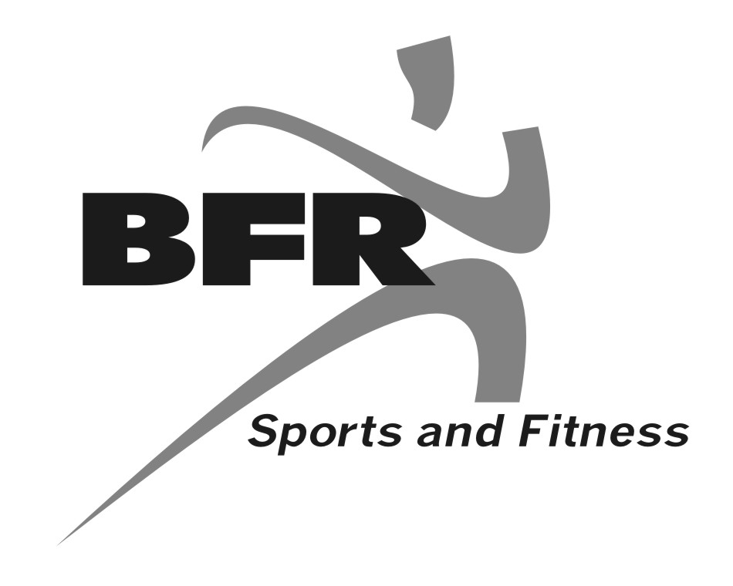
Dear Chamber Member

The BFR will be hosting a FREE Halloween Party (scare free) on Sunday, October 23, 2011 from 2-4pm. Games and crafts 2-3 costume judging at 3. For us to keep this a free community event we are looking for donations. Please see below on how you might be able to help:

Donation 1- Your company/business donates prizes or candy for booths

Donation 2- Your company/business sets up and provides prizes for your choice of booth
(BFR has ideas and materials)

Donation 3- Your company/business provides the cookies and/or drink for snack table

All companies/businesses participating will be able to display their company/business logos during this FREE community event. Recognition will be given to all who volunteer or donate.

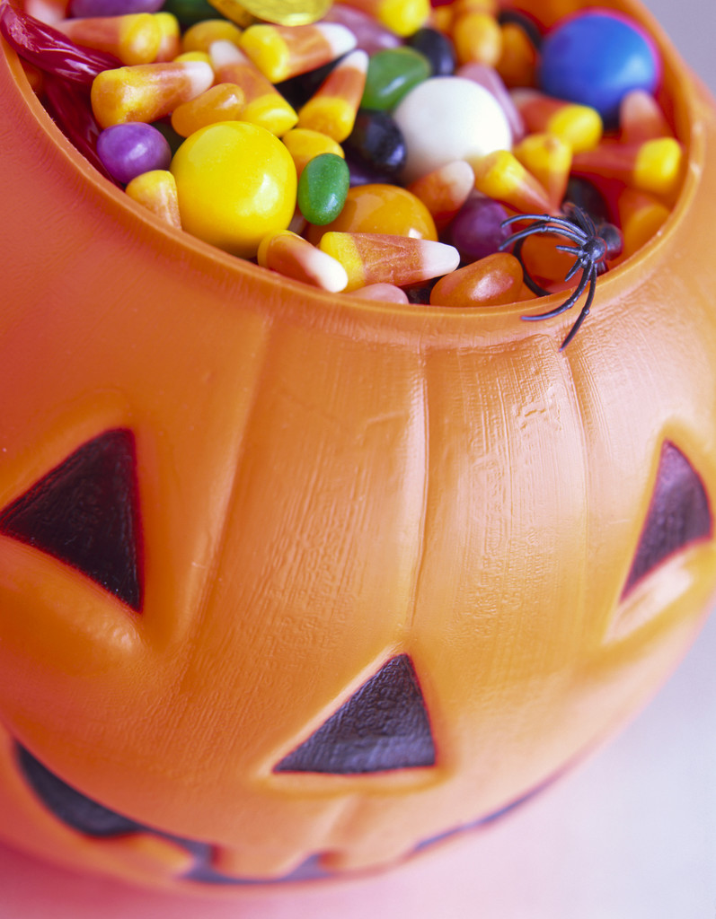
If interested in any of the above please fill out bottom portion and give me a call/or email by Oct. 17!

Thank you,

Maranda P. Miller
419-358-4150
bfrc@wcoil.com

______________________________________________________________________________

Company/Business Name_______________________________________________

Donation 1__________ Donation 2__________ Donation 3__________

Judge (costume contest)_________

Phone #_______________________________

Contact Person_________________________

