**Media Advisory**

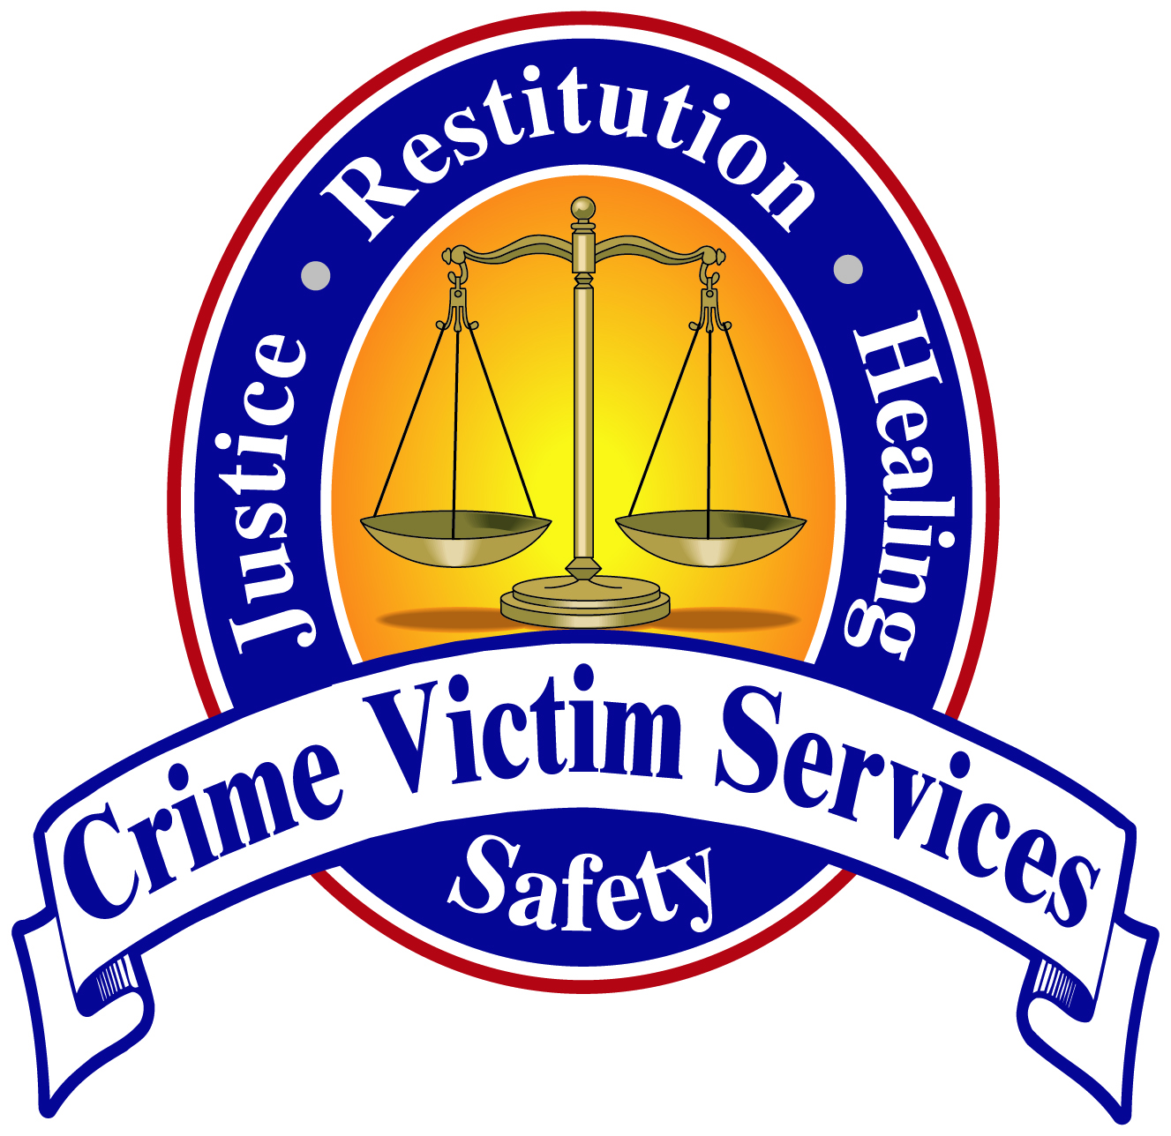

April 25, 2012

Contact: Laurel Neufeld Weaver- Crime Victim Services

Phone: 419-222-8666

**Local Response to Human Trafficking**

**WHAT:** Waiting for Us to Care: Responding to Human Trafficking in our Communities workshop

**WHEN:** Friday, April 27 2012, 9:00 a.m. – 3:00 p.m.

**WHERE:** Bradfield Community Center, 550 S Collett St, Lima, OH

**WHO:** *The attendees are from a variety of first responder agencies as well as health and social service agencies.*

**FEATURED SPEAKER:** *Speaker will be author* ***Theresa Flores****, who travels the country sharing her story of her personal story as a trafficked teenage sex slave from an upper-middle class suburb in Detroit, Mich.*

*Theresa will be available for media interviews immediately following her presentation, approximately 9:45AM*

*Other speakers throughout the day will include Trisha Smouse, Anti-Trafficking Program Coordinator and Legislative Advocate Tabitha M. Woodruff of Central Ohio Rescue and Restore Coalition, Lima Police Investigator Dave Gillispie, and Ken Lawson, Columbus Police Department.*

**WORKSHOP SPONSORS:** *Allen County Rape Crisis Coalition, Northwest Ohio Human Trafficking Rescue and Restore Coalition, Bradfield Community Center Lima, Ohio, Crime Victim Services, and Lima Memorial Hospital*

# # #

Background info: *Attached is a bio of Theresa Flores and fact sheet about human trafficking for your use and information. Thanks.*

Bio:

Theresa Flores LSW, MSeD

Human Trafficking Survivor, Author, Victim’s Advocate, Founder of S.O.A.P. (Save Our Adolescents from Prostitution),

Director of Education & Training for Gracehaven House

Ms. Flores has been a licensed Social Worker for over twenty years. She received her Master’s in Counseling Education from University of Dayton and a Bachelor’s of Social Work from Ball State University. She is the spokes woman and Director of Education & Training for Gracehaven House, a ten-bed long-term faith based rehabilitation home for girls under the age of 18 who have been victimized by human trafficking.

Ms. Flores was appointed to the Ohio Attorney General’s Human Trafficking Commission in 2009 and has testified before the Ohio House and Senate in supports of Human Trafficking Legislation. Her efforts were a major part of the success of SB235 being passed into law by Governor Strickland on Dec. 23rd, 2010.

Ms. Flores was recognized by current Ohio Governor Kaisch and received the **Courage Award** for her work in human trafficking.

She is a much sought after international speaker and lectures on many aspects of Human Trafficking from both a personal perspective as well as a professional expert. She has trained children services workers, judges, probations officers, guest lectures at universities and speaks with middle and high school students nationwide.

Ms. Flores is featured by the National Underground Railroad Freedom Center

Museum in a traveling exhibit entitled, Invisible Slavery and has published two books, “The Sacred Bath” and “The Slave Across the Street”. The audio version of her latest book was nominated for The 2011 Audie Award, being in the top 5 of all memoirs and biographies.

Her story has been seen on The Today Show & MSNBC: Sex Slaves-The Teen Trade. Nightline and America’s Most Wanted. Ms. Flores was awarded the honor of Columbus' 2009 “20 Women You Should Know,”' The 2009 Soroptimist "Women Making A Difference" award and the 2010 Ruby Award.

HUMAN TRAFFICKING



## *The Victims of Trafficking and Violence Protection Act defines “severe forms of trafficking in persons” as:*

## *Sex trafficking in which a commercial sex act is induced by force, fraud, or coercion, or in which the person induced to perform such an act has not attained 18 years of age; or,*

## *The recruitment, harboring, transportation, provision, or obtaining of a person for labor or services through the use of force, fraud, or coercion for the purpose of subjection to involuntary servitude, peonage, debt bondage, or slavery.*

## Globally:

## According to Secretary of State Hillary Clinton, there “are as many as 27 million men, women and children” in forced labor, bonded labor, and forced prostitution around the world.

## In 2010 the total number of identified trafficking victims was 33,113 world-wide.

## Human trafficking is the second largest criminal industry in the world, preceded by the selling of drugs

## In the United States:

## In the U.S., 80% of human trafficking was classified as sex trafficking.

## 83% of victims in confirmed sex trafficking incidents were identified as U.S. citizens.

## We can prove that 100,000 American children a year are trafficked.

## There are 1.7 million runaways in the U.S. and they are at the highest risk for being trafficked.

## 1 in 4 girls and 1 in 6 boys will experience some form of sexual abuse before the age of 18.

## In Ohio:

## According to a 2010 prevalence study done for the attorney general, approximately 1,000 runaway and homeless minors are at risk for exploitation in Ohio’s commercial sex trade every year.

## Toledo’s Northwest Ohio Innocence Lost Task Force has identified 60 minor victims of sex trafficking since it started in 2006, which 75 % (45) were from Lucas County. Ohio has been involved in almost every national investigation into domestic minor sex trafficking since the passing of the Trafficking Victims Protection Act of 2000. Those include: Operation Precious Cargo, and Operation Cross Country I, II, III, and IV.

## Statistics from: Extending the Vision Reaching Every Victim. U.S. Department of Justice: Office of Justice Programs: Office for Victims of Crime. January 2012. <http://ovc.ncjrs.gov/ncvrw2012/pdf/2012ResourceGuide.pdf>

## What You Need to Know

## Human Trafficking is slavery

## It’s happening where you live

## It’s happening to people just like you.

## **Resources**

## **The Polaris Project**

## Polaris Project is a leading organization in the United States combating all forms of human trafficking and serving both U.S. citizens and foreign national victims, including men, women, and children. We use a holistic strategy, taking what we learn from [our work with survivors](http://www.polarisproject.org/what-we-do/client-services) and using it to guide the creation of long-term solutions. We strive for systemic change by [advocating for stronger federal and state laws](http://www.polarisproject.org/what-we-do/policy-advocacy), operating the [National Human Trafficking Resource Center](http://www.polarisproject.org/what-we-do/national-human-trafficking-hotline/the-nhtrc/overview) hotline 1.888.3737.888, and providing services to help our clients and all victims of human trafficking.

<http://www.polarisproject.org/>

## **National Human Trafficking Resource Center**

The National Human Trafficking Resource Center (NHTRC) is a national, toll-free hotline, available to answer calls from anywhere in the country, 24 hours a day, 7 days a week, every day of the year.

<http://www.polarisproject.org/what-we-do/national-human-trafficking-hotline/the-nhtrc/overview>



**Shared Hope International**: Leading a Worldwide Effort to Eradicate Sexual Slavery…one life at a time.

<http://www.sharedhope.org/Home.aspx>

**Fact Alliance**: Fight Against Child Trafficking.

<http://www.letsrespond.com/home.htm>

**U.S. Department of State**: Office to Monitor and Combat Trafficking in Persons.

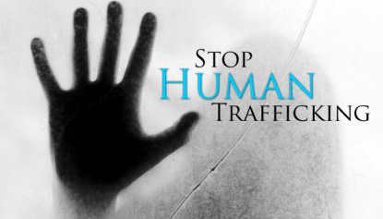<http://www.state.gov/j/tip/>